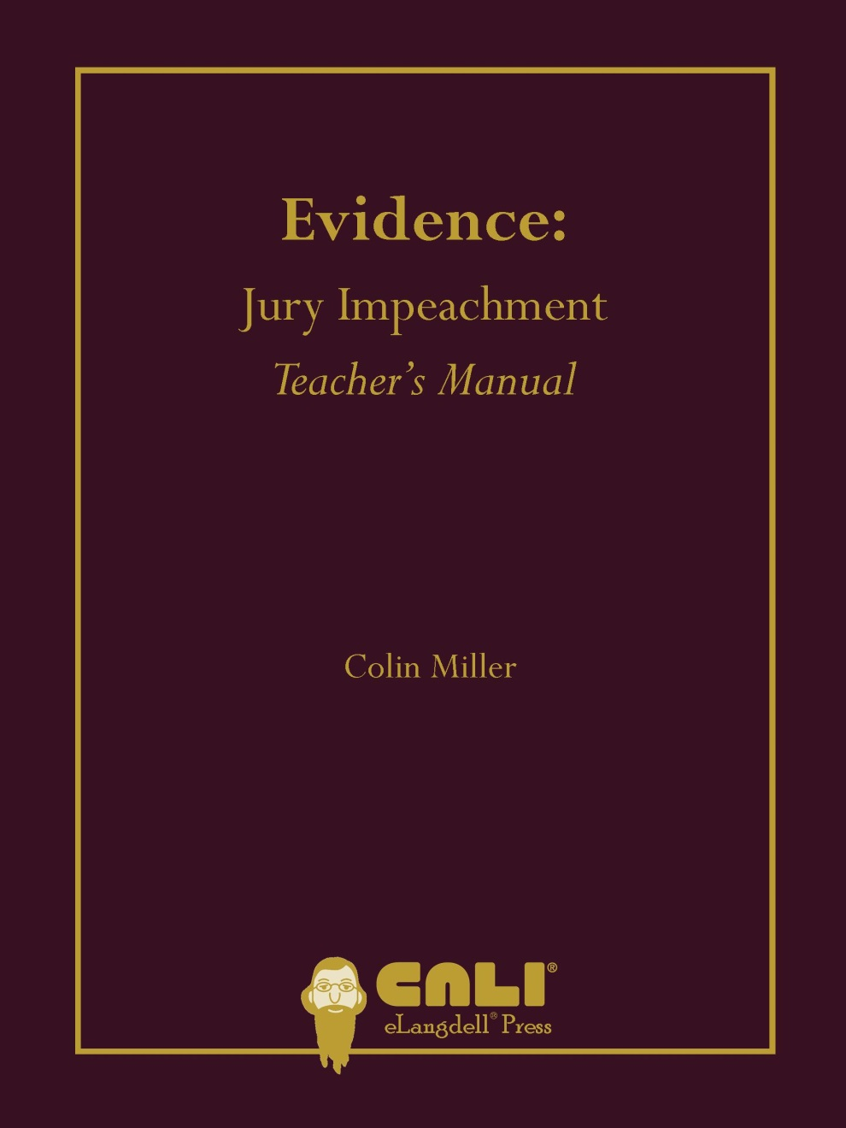

Jury Impeachment Chapter Teacher’s Manual
Section I sets forth the text of Rule 606(b).
Section II sets forth the history origins of Rule 606(b). You can highlight that
- Even under Mansfield’s Rule, an eavesdropped could testify about overheard jury deliberations. Justice O’Connor’s citation to United States v. Taliaferro in Tanner (page 10) reveals that the continuing viability of this conclusion; and
- In Pless, the Court held that prioritizing the privacy of jury deliberations over redressing the injury of a private litigant in a civil case was “the lesser of two evils.” The Court did not address whether the same calculus applies when the injury is the incarceration of a criminal defendant.
The main point in Section III is the distinction between the House and Senate drafts of Rule 606(b). At this point, it might be good to ask students about their initial impression of whether the correct version was chosen by asking students whether jurors should be able to testify about quotient verdicts and verdicts reached through chance.
Section IV sets forth the three primary public policy rationales given by the Advisory Committee for having a strong anti-jury impeachment rule. At this point, you can ask whether these rationales change the way that they initially felt about Rule 606(b).
Section V contains an excerpted version of the Supreme Court’s landmark opinion in Tanner. You can highlight that Justice O’Connor
- rejects a rigid locational distinction in which Rule 606(b) only applies to events outside the jury room and never applies to events inside the jury room (pages 8). Students need to be able to understand the exact nature of the external/internal distinction;
- questions whether the jury system could survive increased investigation into juror misconduct (page 8). You can use this as an opportunity to ask students whether this observation is accurate and whether a system that cannot survive increased scrutiny deserves to survive;
- analogizes juror drug and alcohol abuse to a virus, poorly prepared food, or a lack of student (page 8). You can ask students whether these analogies hold water;
- concludes that petitioners’ Sixth Amendment right to an unimpaired jury is protected by several aspects of the trial process of voir dire and the observations or the court, counsel, court personnel, and other jurors. You can ask students whether they think that these protections are sufficient.
Section VI discusses the external/internal distinction recognized by Justice O’Connor in Tanner. At this point, you might want to lay out several examples and ask students on which side of the distinction they fall based upon Justice O’Connor’s analysis.
Hypothetical 1 is an example of a compromise verdict, which the Court of Appeals of Texas found was internal to the jury deliberation process and could not form the proper predicate for jury impeachment.
Hypothetical 2 is an example of jurors misunderstanding jury instructions and the consequences of their verdict. The Fifth Circuit found that these matters were internal to the jury deliberation process and could not form the proper predicate for jury impeachment.
Section VI.A. discusses the exception to Rule 606(b) for extraneous prejudicial information. You can highlight the common definition of extraneous prejudicial information, which is “information that was not admitted into evidence but nevertheless bears on a fact at issue in the case.”
Hypothetical 3 is interesting because in Bradford, the jury apparently considered testimony that was initially properly admitted but later stricken. Consistent with every other opinion that I have seen on the issue, the Ninth Circuit in Bradford found that this testimony was not extraneous prejudicial information and thus could not form the proper predicate for jury impeachment.
Hypothetical 4 involves a clear case of extraneous prejudicial information reaching the jury and forming the proper predicate for jury impeachment. While the Northern District of California allowed for jury impeachment, it ultimately did not disturb the verdict because “there was no discussion or consideration of the substance of Juror No. 8's remarks.”
If the opinions originated with Juror No. 8 and not her husband, the vast majority of courts would find that the statements would not allow for jury impeachment under Rule 606(b). And while some courts do find that the Constitution trumps Rule 606(b) in cases of juror racial/ethnic bias, this typically occurs in criminal rather than civil cases.
If Juror No. 8 indicated during voir dire that ethnicity would not influence her decision as a juror in any way, most courts would allow for jurors to testify about her comments to prove that she lied during voir dire, which could lead to the verdict being vacated.
Hypothetical 5 comes from Sidney Lumet’s classic movie, “12 Angry Men.” Clips of the scene in question are obtainable on the internet – see, e.g., http://www.youtube.com/watch?v=W8trhBy2DLE -- and can be played in class. It seems clear that evidence of the knife is extraneous prejudicial information which would allow for jury impeachment.
Section VI.B. discusses the exception to Rule 606(b) for improper outside influences. You can highlight that this exception only covers conduct by nonjourors.
Hypothetical 6 is a case of an improper outside influence, not extraneous prejudicial information. In Lewis, the court found that the communication between Hughes and the detective did not constitute extraneous prejudicial information because Hughes already knew about the failed polygraph test and communicated this knowledge to the court. The court did, however, find that the detective's statement about "do[ing] the right thing" constituted an improper outside influence because it clearly evinced an intent on the detective's part to try to influence Hughes into finding the defendant guilty. The court then determined that the statement was sufficiently prejudicial to entitle the defendant to a new trial.
Hypothetical 7 involves two cases of intrajury pressure. The courts in these cases, like other courts in similar cases, concluded that these were not improper outside influences and could not form the proper predicate for jury impeachment.
Section VII.C. discusses the recent exception to Rule 606(b) for clerical errors. You can highlight that this exception only covers errors in reducing the verdict to the verdict form, not errors in understanding jury instructions or how to reach a verdict.
Hypothetical 8 is a case in which the Supreme Court found that juror testimony regarding the clerical error should have been admissible. Although this is an old case, I think that it provides a cleaner example of the new exception contained in Rule 606(b)(3) than any case decided after its adoption.
Hypothetical 9 is an example of a case in which a court found that the clerical exception did not apply. The facts are not the exact facts from Lyons, but they express of the gist of what was presented to the Court of Appeals of North Carolina. That court found that the subject error was not an impeachable clerical error because “the affidavits address[ed] ‘the intention of the jury’ and how the jury ‘understood’ that the amounts set out in the verdict sheet would be applied.” In other words, there was no transcription mistake because the foreperson wrote down exactly what the jurors agreed to write on the verdict form.
Section VII.A. clarified that Rule 606(b) only prohibits testimony by jurors, not testimony by others who might have observed misconduct connected with the jury.
Hypothetical 10 is an example of a case in which a court permitted a nonjuror – the bailiff – to testify regarding (his own) misconduct. While the court allowed the bailiff’s testimony, the Supreme Court of Nevada ultimately affirmed Lamb’s conviction, concluding that there was not a reasonable probability that the bailiff’s comment influenced the jury’s verdict.
Section VII.B. notes that Rule 606(b) only precludes jury testimony offered to impeach the validity of a verdict. You should highlight the fact that courts increasingly have begun precluding juror testimony to offered to prove that a juror lied during voir dire.
Section VIII.A. discusses the fact that some states have no counterparts to Federal Rule of Evidence 606(b) or rules that sweep less broadly. At this point, you might want to revisit the issue of how broad the anti-jury impeachment rule should be.
Section VII.B. discusses Minnesota’s violence exception to Rule 606(b). There are several questions in the subsection that can lead to a renewed discussion of the extent to which the jury deliberation process should be a black box.
Section VIII.C. discusses the split among courts about whether jurors should be able to testify about the effect that extraneous prejudicial information or an outside improper influence had on jury deliberations. It seems to me that the correct answer to the question posed at the end is that jurors should not be able to testify about effects.
Section VIII.D. discusses the split among courts over whether jurors can testify concerning bias expressed by jurors during deliberations. This can lead to a discussion of the extent to which the Sixth Amendment should “trump” the rules of evidence and the relationship between the Constitution and the rules of evidence generally.
Section IX provides citations to three jury impeachment pleadings. Students reading one or more of these pleadings can gain an understanding of how they would use the material in this chapter to draft or oppose a motion with regard to evidence covered Rule 606(b).

