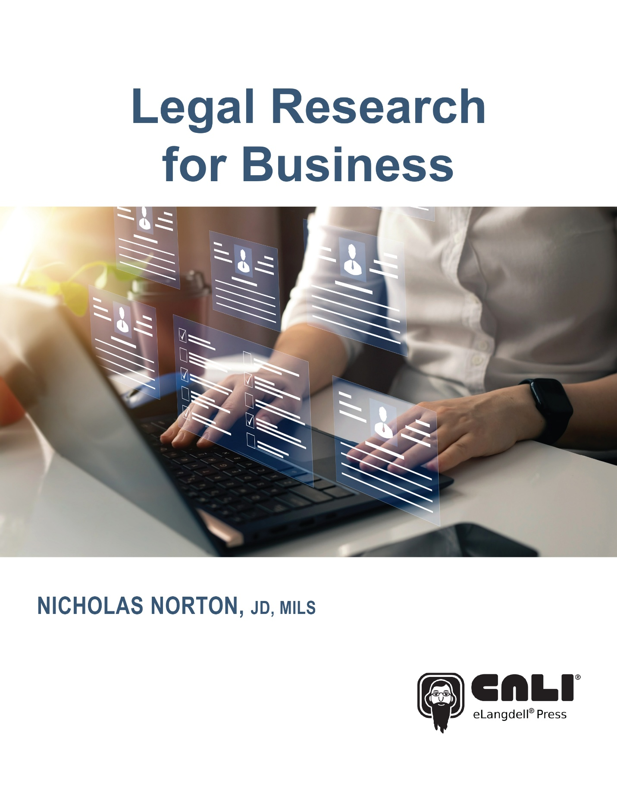

Legal Research for Business

First Edition

Nicholas Norton, JD, MILS
CALI eLangdell® Press 2025

Legal Research for Business

First Edition

Nicholas Norton

© 2025 Center for Computer Assisted Legal Instruction (CALI)

Print ISBN: 979-8-89904-036-8

Ebook ISBN: 979-8-89904-035-1

About the Author

Nicholas Norton is a Blended Practice Area Consultant at Lexis-Nexis. In his previous work as the Research Resources & Inclusivity Initiatives Librarian and Adjunct Professor of Law at Cornell Law School, Mr. Norton instructed students in both basic legal research and business research. He attended Wayne State University for his B.A, J.D., and M.I.L.S. degrees before working at Cornell. He is a member of the Michigan Bar.

About eLangdell Press

The Center for Computer-Assisted Legal Instruction (CALI®) is: a nonprofit organization with over 200 member US law schools, an innovative force pushing legal education toward change for the better. There are benefits to CALI membership for your school, firm, or organization. eLangdell® is our electronic press with a mission to publish more open books for legal education.

How do we define "open?"

- Compatibility with devices like smartphones, tablets, and e-readers, as well as print.
- The right for educators to remix the materials through more lenient copyright policies.
- The ability for educators and students to adopt the materials for free.

Find available and upcoming eLangdell titles at elangdell.cali.org. Show support for CALI by telling your friends and colleagues where you received your free book.

Notices and Permissions

CALI gratefully acknowledges permission from the following individuals and organizations to reprint materials:

Figure 1: Screenshot, Accessing Write-Law on Thomson Reuters’ website.

Figure 2: Screenshot, The Practical Law homepage, accessible via Westlaw. Reprinted from Thomson Reuters with permission. Copyright Thompson Reuters 2025. All rights Reserved.

Figure 3: Screenshot, The Lexis+ homepage, with Practical Guidance available to select on the side panel.

Figure 4: Screenshot, Accessing the transactional precedent search bar on Bloomberg Law.

Figure 5: Screenshot, The homepage of Bloomberg Law.

Figure 6: Screenshot, The Bloomberg Law Business Intelligence Center.

Figure 7: Screenshot, Bloomberg Law, Company Information Page for Clorox, Inc. Accessed:

Figure 8: Screenshot, Homepage of Lexis+.

Figure 9: Screenshot, Hoover’s company records search page on Lexis+.

Figure 10: Screenshot, Hoover’s company report for Walt Disney company on Lexis+. Accessed:

Figure 13: Screenshot, Result of an SEC filings search on Bloomberg Law.

Figure 14: Screenshot, Example of the Google News Interface.

Figure 15: Screenshot, . An example of creating a news alert from a company dashboard on Bloomberg Law.

Figure 16: Screenshot, Lexis+ Homepage.

Figure 17: Screenshot, Example of the Wall Street Journal website company information on Clorox Inc.

Figure 22: Screenshot, The interface for searching for a country research guide on GlobaLe

Figure 23: Screenshot, The Researching Canadian Law guide written by an expert in the area, in GlobaLex.

Figure 24: Screenshot, Example Bloomberg Law Company Dashboard for a non-U.S. company.

About This Book

This is the first edition of this book, published July, 2025. Visit http://elangdell.cali.org for the latest version and for revision history.

This work by Nicholas Norton is licensed and published by CALI eLangdell Press under a Creative Commons Attribution-NonCommercial-ShareAlike 4.0 International (CC BY-NC-SA 4.0).

In brief, the terms of that license are that you may copy, distribute, and display this work, or make derivative works, so long as:

- you give CALI eLangdell Press and the author credit;
- you do not use this work for commercial purposes; and
- you distribute any works derived from this one under the same licensing terms as this.

Suggested attribution format for original work:

Nicholas Norton, Legal Research for Business, Published by CALI eLangdell® Press (2025). Available under a Creative Commons BY-NC-SA 4.0.

CALI and eLangdell® are trademarks protected by United States federal and common law and owned by The Center for Computer-Assisted Legal Instruction. The cover art design is a copyrighted work of CALI. Permission is granted to use the cover art in conjunction with using other parts of this book under its Creative Commons license.

This material does not contain nor is intended to be legal advice. Users seeking legal advice should consult with a licensed attorney in their jurisdiction. The editors have endeavored to provide complete and accurate information in this book. However, CALI does not warrant that the information provided is complete and accurate. CALI disclaims all liability to any person for any loss caused by errors or omissions in this collection of information.

First Edition: Updated July, 2025

Table of Contents

About the Author i
About eLangdell Press ii
Notices and Permissions iii
About This Book v
Introduction ix
Chapter 1 What is ‘Legal Research for Business’? 1
1.1 Learning Objectives for Chapter 1 1
1.2 Introduction 1
1.3 What is Legal Research? 1
1.4 What is Legal Research for Business? 4
1.5 Tips on Workflow Management 5
1.6 Application 11
1.7 Concluding Exercises for Chapter 1 13
Chapter 2: Entity Formation & Transactional Precedent Searching 15
2.1 Learning Objectives for Chapter 2 15
2.2 Introduction 15
2.3 The Basics of Entity Formation 15
2.4 Transactional Precedent Searching 17
2.5 Application 18
2.6 Concluding Exercises for Chapter 2 19
Chapter 3: Publicly Traded Companies 21
3.1 Learning Objectives for Chapter 3 21
3.2 Introduction 21
3.3 Finding Company Information 21
3.4 Application 28
3.5 Exercises for Chapter 3 29
Chapter 4: Administrative Law Legal Research for Business 31
4.1 Learning Objectives for Chapter 4 31
4.2 Introduction 31
4.3 The Securities & Exchange Commission 31
4.4 Non-SEC Regulatory Agency Research 37
4.5 Application 37
4.6 Concluding Exercises for Chapter 4 38
Chapter 5: Privately Held Companies 40
5.1 Learning Objectives for Chapter 5 40
5.2 Introduction 40
5.3 Privately Held Companies 40
5.4 Application 41
5.5 Concluding Exercises for Chapter 5 42
Chapter 6: Company News 44
6.1 Learning Objectives for Chapter 6 44
6.2 Introduction 44
6.3 Sources for Staying Current 44
6.4 Writing About Company News 49
6.5 Application 50
6.6 Concluding Exercises for Chapter 6 50
Chapter 7: Campaign Finance Research 51
7.1 Learning Objectives for Chapter 7 51
7.2 Introduction 51
7.3 Campaign Finance Basics 51
7.4 Application 55
7.5 Concluding Exercises for Chapter 7 56
Chapter 8: Foreign, Comparative, and International Business Legal Research 57
8.1 Learning Objectives for Chapter 8 57
8.2 Introduction 57
8.3 Basics of Non-U.S. Legal Research 57
8.4 Basics of Non-U.S. Company Information 59
8.5 Application 62
8.6 Concluding Exercises for Chapter 8 62
Appendix A - Writing a Due Diligence Report Exercise 63
Appendix B - Compliance Lighting Talks Exercise 64

Introduction

The material in this book was developed and used in a one credit Advanced Legal Research for Business course that I taught at Cornell Law School from 2022 to 2024. I wrote this book to fill a gap in the law school curriculum. Legal research skills are often overlooked in law school, and research skills applied to a particular context like business are even more overlooked. Many law students will go on to be attorneys working in corporate or business practice. This book aims to equip them with skills helpful at the beginning of their careers.

This book is organized into eight chapters. First, the book walks students through the basic legal research process. This will ensure that all students are on equal footing and set a baseline competency level. Next, the basics of company formation is discussed. This includes how to locate transactional forms. Chapters three, four, and five discuss company information, the various places where that data can live, the administrative law sources of this information, and the difference between researching a publicly traded and privately held company. Chapters six through eight discuss special topics in this area. Chapter six discusses company news, staying current, and news aggregators. Chapter seven explores researching campaign finance and the political activity of a company. Finally, chapter eight details foreign and international research for companies. Each chapter can be covered in one or two class sessions for a one credit course, with the remainder of the semester being used for group and individual exercises, or presentations on relevant topics.

Chapter 1 What is ‘Legal Research for Business’?

1.1 Learning Objectives for Chapter 1
Reading this chapter will help students understand:

- The basic legal research process
- What makes legal research distinct in a business context
- Methods for successfully managing research priorities and workflow management

1.2 Introduction

Welcome to this introduction to legal research for business. A variety of law school classes (such as corporations, mergers and acquisitions, secured transactions, and others) introduce students to the business world. Many will leave law school and be expected to apply the concepts from these doctrinal classes to real-world matters. Clinical education in law school may expose students to the practical work of corporate lawyering, but not every student who eventually enters a business law practice area will have the opportunity to take that specific type of law school clinic. Therefore, this text strives to expose future lawyers to the sources of information relevant to business research. This chapter will remind us of the basic legal research process, see what makes the research process unique in a business context, before finally discussing general tips to keep organized while working on a research project.

1.3 What is Legal Research?

Lawyers work in a wide variety of contexts – courts, regulatory agencies, corporate offices, and many other settings employ lawyers doing diverse work. The one thing that unites these lawyers in these very different settings, however, is that they all do research. What is legal research, though? According to Legal Research in a Nutshell:
Legal research is the process of identifying the legal rules that govern an activity and finding sources that explain or analyze those rules. Successful research gives you confidence that you’re not missing any important pieces that might undermine the conclusions you reach.
When a lawyer is presented with a legal research question, a typical approach would see them start by identifying relevant issues to research, consult a secondary source, identify relevant primary sources, use relevant citator services on legal research platforms, repeat the previous steps as necessary, and then finally synthesize their research into work product of some kind.
Put another way, the researcher will receive their assignment > make a research plan > perhaps consult old work product / templates if they have worked on this topic before > review a secondary source to either a) get up to speed on a topic for the first time, b) see if there have been updates in an area of law they work in all the time, c) make sure they are finding the right primary authority > read through relevant primary authority (cases, statutes, regulations, etc.) > use tools like headnotes, Westlaw key numbers, etc. to see if there are even more relevant results they had not located yet > use a tool like Shepard’s reports or KeyCite to see if the sources they are citing to are current > potentially repeat any of the steps from above > then start writing or orally synthesizing their findings.
Modern generative artificial intelligence technology is also impacting the legal research process. LexisNexis’s Protege and Westlaw’s CoCounsel allow users to prompt for research assistance, document drafting assistance, and summarizing large amounts of information. The use of generative AI technology for legal research is rapidly evolving over time, and it is important for a legal researcher to consult with their employer’s and state bar’s specific guidance on how to proceed with using these tools.

Say that an attorney has a client come into their New York office. The client is looking for help with a divorce from their spouse. After the researcher identifies what topic they are researching (New York family law) they may next consult a secondary source on that subject. Why would this attorney use a secondary source? Secondary sources provide clear explanations for many areas of law, summarize the applicable cases and statutes from a variety of jurisdictions, and overall serve as an excellent starting point for research. For example, consulting a legal encyclopedia (like New York Jurisprudence) would be valuable to get an introduction to the legal topic they are looking into. After brushing up on that area of the law using a secondary source, they may then move on to look up whatever primary source material they might need. Below is a chart showing a variety of places to look for both primary and secondary source legal information.

Source | Information
Government websites | Court dockets (depending on the jurisdiction), court decisions, agency regulations, statutes
Lexis, Westlaw, Bloomberg Law, Fastcase, etc. | Secondary sources, primary sources, dockets
Google Scholar | Scholarly articles, case law
HeinOnline | Law review articles, curated collections, legislative histories
ProQuest Congressional | Legislative histories
JSTOR, etc. | Social science literature
Libguides (sometimes called library research guides) | Helps to find secondary sources (treatises, law review articles, etc.)
Where to find common secondary and primary sources

1.4 What is Legal Research for Business?

Now that we have a foundation for the typical legal research process, what makes legal research for business distinct? In a typical legal research introductory course, students will spend time finding secondary sources that lead them to cases and statutes. Cases and statutes are important in the world of business legal research, however, a business legal researcher may also have to conduct due diligence on a company or matter. Due diligence can be defined as "an investigation, audit, or review performed to confirm facts or details of a matter under consideration." Transactional attorneys may have to spend a great deal of their time conducting these kinds of due diligence investigations and drafting due diligence reports of some kind. Due diligence reports written on a publicly traded company may contain a multitude of information. Some themes that may be covered could include:

- Background information on the company, such as the following:
  - Name
  - State of incorporation
  - Address
  - Industry
  - Current board and officers
  - Short history
  - Ticker symbol
  - Number of employees
- Financial information, such as:
  - Annual report
  - Income
  - Balance sheet
  - Stock market reports
- Recent developments:
  - Acquisitions
  - New Products
- Risks to which the company is exposed, such as:
  - Litigation
  - Regulatory oversight
  - Competition
Note that due diligence is conducted for many different purposes. In the context of a merger and acquisition, the scope of the due diligence required might look different than a general counsel preparing securities filings. Due diligence is also something that is often a team effort where lawyers, underwriters, and accountants each contribute to a larger body of research.

1.5 Tips on Workflow Management

After exploring the basics of legal research and what makes legal research in a business context distinct, it is helpful to discuss methods for workflow management in a workplace. After all, lawyering is a job. Some of the skills related to doing professional lawyering are common across fields, but some are unique to being an attorney. This section will cover some of the basics for how to stay organized as a new legal professional.
Merriam-Webster’s Dictionary has multiple definitions of the term ‘professional,’ including:

(1): characterized by or conforming to the technical or ethical standards of a profession
(2): exhibiting a courteous, conscientious, and generally businesslike manner in the workplace
Law students entering the workplace must consider both definitions when entering their first work experiences. They are trying to conform to the ‘technical and ethical standards’ of the lawyering profession, while also aiming to be seen as courteous in the workplace. It is important to note that professionalism is not an objective standard that is applied equitably to all. While learning how to conduct legal research in the business context, however, it would be a disservice not to mention some strategies for making a student a successful professional.
Some common themes that lawyers may struggle with when transitioning from law student to their first work experience include:

- Prioritization
  - Staying organized
  - Balancing competing priorities
  - Knowing when to ask for help
- Legal technology (including word processing, spreadsheets, email management, etc.)
- Professional communication

Lawyers will face many conflicting priorities. For example, you might have a medical appointment, take a child to school, have a deadline at work move up unexpectedly, and a new client meeting that cannot be cancelled all conflicting with one another. It can be difficult to move competing priorities forward simultaneously, or how to differentiate between a top priority and something that can be postponed for later. What to prioritize is not always a simple question with a clear right answer, but staying organized is a helpful first step. This is helpful not only to the researcher as an individual but also to the teams that they are working with. You can stay organized in a number of ways, such as:

- Keeping a list of all your search terms, relevant secondary sources, relevant primary sources, etc. in a word document
- Organizing that content in a spreadsheet
- Writing notes by hand
- Using folders in one of the legal research platforms to organize results
Whatever research plan method you use, the researcher will want it to be organized in case they have to a) work on a project over a long period of time or b) have to hand someone else the research done so far to get others up to speed or if they have to take over a project. Consider using a research log like the example below:

Research Question

In your own words, what is your research question?

Fact Analysis
Categories of Information | Facts | Notes
Parties involved (“Who”)
Describe the parties (e.g. landlord and tenant)
Things and Actions (“What”)
These might include the following:
• Tangible objects (e.g. automobiles)
• Intangible objects (e.g. vacation or reputation)
• Parties’ conduct (acts done and not done)
• Parties’ mental states
Places (“Where”)
• Geographic location (e.g. New York)
• Type of location (e.g. school or church)
Legal terms of art, claims, defenses, remedies, etc.
Research Log

Categories of Information | Results | Notes
Search Terms | [search term a], [search term b], [search term c]
Secondary Sources  Treatises, encyclopedias, articles, etc. | Platform x > [search term] > # of results:  - Useful result 1  - Useful result 2  Platform y > [search term] > # of results:  - Useful result 1  - Useful result 2
Primary Sources  Statutes, cases, regulations, etc. | Platform x > [search term] > # of results:  - Useful result 1  - Useful result 2  Platform y > [search term] > # of results:  - Useful result 1  - Useful result 2
Citators  Shepard’s, Keycite, headnotes, etc. | [useful headnote 1], [useful headnote 2], [useful headnote 3]

In addition to staying organized, legal technology involves more than just knowing how to use Lexis, Westlaw, and Bloomberg Law (though that can often be challenging in and of itself). It is important for a new lawyer to also be adept at using more basic workplace tools such as Microsoft Word, Excel, and Outlook. Practice using these tools before entering the legal workplace (or make an appointment with a librarian or IT professional at your workplace) to be best prepared for success. Explore the following on your own computer:

- Making a table of contents in Microsoft Word
- Using an email calendar in Gmail or Outlook
  - Automated replies
  - Rules / folders
- Using shared document systems like DropBox or Box

Below is a screenshot from Write.Law found on Westlaw that covers some of the basics of how to use tools like word processors and email.

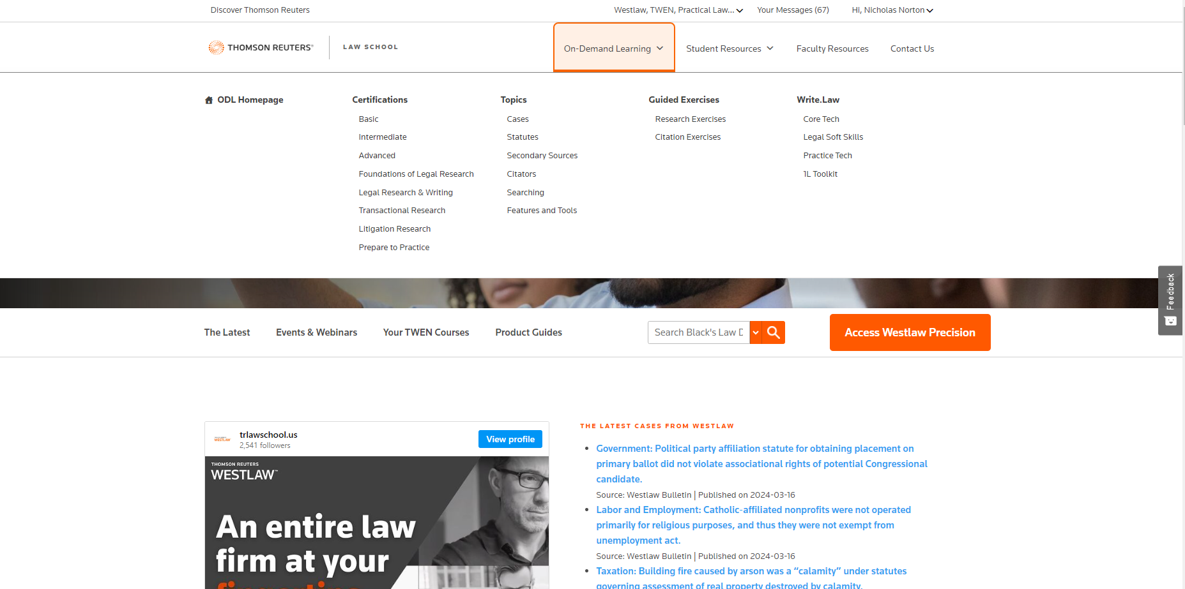
Figure 1. AccessingWrite-Law on Thomson Reuter’s website

In terms of professional communication, explaining research or responding to stressful situations via email can be very difficult when entering a first work experience. Have a frank conversation with a new supervisor in terms of what typical email correspondence looks like, how memoranda are formatted, and if in person communication is preferred over other modalities. The workflow management exercise at the end of this chapter provides examples of the kinds of questions a new lawyer can discuss with their boss. By establishing clear communication expectations, the new lawyer will be more likely to have a positive work experience.

1.6 Application

Suppose that we are researching a standard legal research question and trying to develop a research plan to get started. Read through the problem below and take notes on how you would conduct the research yourself before reading the example answer.

Hypothetical: You work at a law firm specializing in representing businesses in the horse-racing industry. Our client operates an auction house that deals in various breeds suitable for show jumping and eventing. We've been informed that an employee of our client, responsible for preparing and presenting these horses to potential buyers, allegedly misrepresented the health and fertility of certain animals prior to their sale. Specifically, buyers who acquired two horses from our client's auction in Ohio are now claiming that this employee concealed pre-existing injuries and other health issues. Consequently, these buyers are initiating legal action against our client in Ohio. We need to analyze the details of these claims and prepare a robust defense strategy to protect our client's interests.

Research Question: Is the client liable for the buyer's claim related to concealing injuries to this horse?

Fact Analysis
Categories of Information | Facts | Related Terms
Parties involved (“Who”)  Describe the parties (e.g. landlord and tenant) | Client, employee, buyer
Things and Actions (“What”)  These might include the following:  • Tangible objects (e.g. automobiles)  • Intangible objects (e.g. vacation or reputation)  • Parties’ conduct (acts done and not done)  • Parties’ mental states | Client owns an auction house, employee sold a horse to buyer, buyer says the horse has health problems
Places (“Where”)  • Geographic location (e.g. New York)  • Type of location (e.g. school or church) | Ohio
Legal terms of art, claims, defenses, remedies, etc.

Research Log

Categories of Information | Results | Notes
Search Terms | [Buying a horse injuries], [Concealing injuries horse], [Misrepresenting horse purchase] | Synonyms for fraud like misrepresent were helpful to improving the search results
Secondary Sources  Treatises, encyclopedias, articles, etc. | Lexis > [misrepresent horse injury ] >:  - Ohio Jurisprudence, Third Edition, 50 Oh Jur Fraud and Deceit § 80
Primary Sources  Statutes, cases, regulations, etc. | Leal v. Holtvogt, 123 Ohio App. 3d 51, 702 N.E.2d 1246, 37 U.C.C. Rep. Serv. 2d 953 (2d Dist. Miami County 1998).
Citators  Shepard’s, Keycite, headnotes, etc. | HN1 Negligent Misrepresentation, Elements

As this example shows, the legal researcher went through the process of formulating search terms, consulting a relevant secondary source, finding the appropriate primary sources, before gathering some citator content to lead to additional results.

1.7 Concluding Exercises for Chapter 1

Introduction to Legal Research Exercise

Take this short quiz to test your knowledge of the basic legal research process.

- Is Black’s Law Dictionary a secondary or primary source of legal information?

- Is the Dodd Frank Act (12 USCS § 5301) a secondary or primary source of legal information?

- When you are starting researching a legal issue, which of the following sources would be good to start with to get up to speed on the law generally?
a) A legal encyclopedia like American Jurisprudence
b) A federal statute
c) The Code of Federal Regulations (CFR)
d) Cases are always the best place to start

- If you were in federal court, which citation would generally be more persuasive than the other? Why?
a) Francis v. Kings Park Manor, Inc., 992 F.3d 67 (2020).
b) Adams v. Fan Chen, 830 Fed. Appx. 727 (2020).

- If you were trying to find case law in a jurisdiction that discusses a particular statute, how would you go about it?
a) Pull up the statute on Lexis and look at the annotations to see cases which have mentioned this statute
b) Search the statute cite in quotation marks and filter to cases in the relevant jurisdiction
c) Both of these options
d) None of the above

Professional Skills Exercise
For each email below, write a response on your own that you think is professional.
1. A supervisor emails you the following:
[Your name]:
I have reviewed your research and am troubled by both the lack of detail and also the amount of time you are claiming to have spent on it. 17 hours of research and this is all you found? That’s ridiculous and unacceptable.
Disgruntled Boss
2. A supervisor emails you the following:
[Your name]:
Where is the report on topic x you were assigned? It has been two weeks and I have not heard anything from you in that time. Please advise if you are able to complete this or if I am going to need to do it myself.
Disappointed Boss

Workflow Management Exercise
Imagine that you are a junior associate at a law firm and have to discuss the following topics with your supervisor. What would you say if they posed these questions to you?

- If a supervisor gives you a research task, how long is it appropriate to spend on it if you don’t find any relevant results at first?

- If you don’t understand a research assignment from a supervisor, what are some things you could do to mitigate this?

- If you aren’t able to complete a research assignment by a deadline, what is the best course of action?

- If you are unfamiliar with a task you are expected to do in a word processor or a spreadsheet, what should you do?

- You aren’t sure how to format a memoranda for your boss. What should you do?

Chapter 2: Entity Formation & Transactional Precedent Searching

2.1 Learning Objectives for Chapter 2

Reading this chapter will help students understand:

- The basic difference between various corporate entity types
- Locating forms and checklists to assist with choosing entity formations
- Practice transactional precedent searching

2.2 Introduction

Before proceeding to chapter three and diving deeper into the sources of company information, this chapter provides an overview of the basics of entity formation and locating transactional precedent templates. Legal research for business takes place in a variety of contexts. While some attorneys may only be advising larger corporations, others will need to help smaller businesses get formed in the first instance. This chapter will introduce the various entity types available to U.S. businesses and some of the ways that attorneys locate transactional documents relevant to the start and maintenance of these entities.

2.3 The Basics of Entity Formation

There are nine common ways of doing business in the United States, specifically:
- Sole proprietorships
- General partnerships
- Limited partnerships
- Limited liability partnerships
- Limited liability companies
- Business corporation
- Professional corporation
- S corporation
- Close corporation

The major differences between these nine structures are (1) how they are created, (2) how they are regulated, (3) how they are managed, (4) how profits are made / distributed, (5) who is liable for the entity’s activities, (6) the duration or how they are terminated, and (7) how they are taxed.

Here are some important questions to ask when considering entity formation:

- What type of business is this?
- What jurisdiction are you in?
- What entity is appropriate? Would choosing one entity over another be more advantageous?

Practical Law (on Westlaw), Practical Guidance (on Lexis+), and Bloomberg Law all have useful secondary sources to research the various entity formation options. For example, a legal researcher could search in Practical Law for a checklist on how to start a limited liability company in the state of New York.

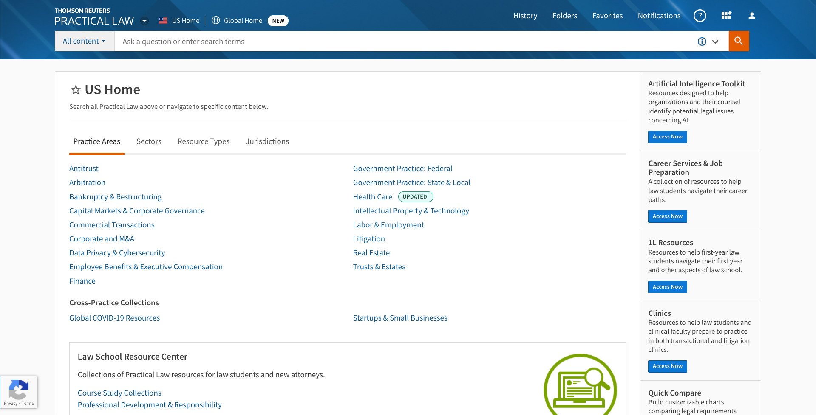
Figure 2. The Practical Law homepage, accessible via Westlaw

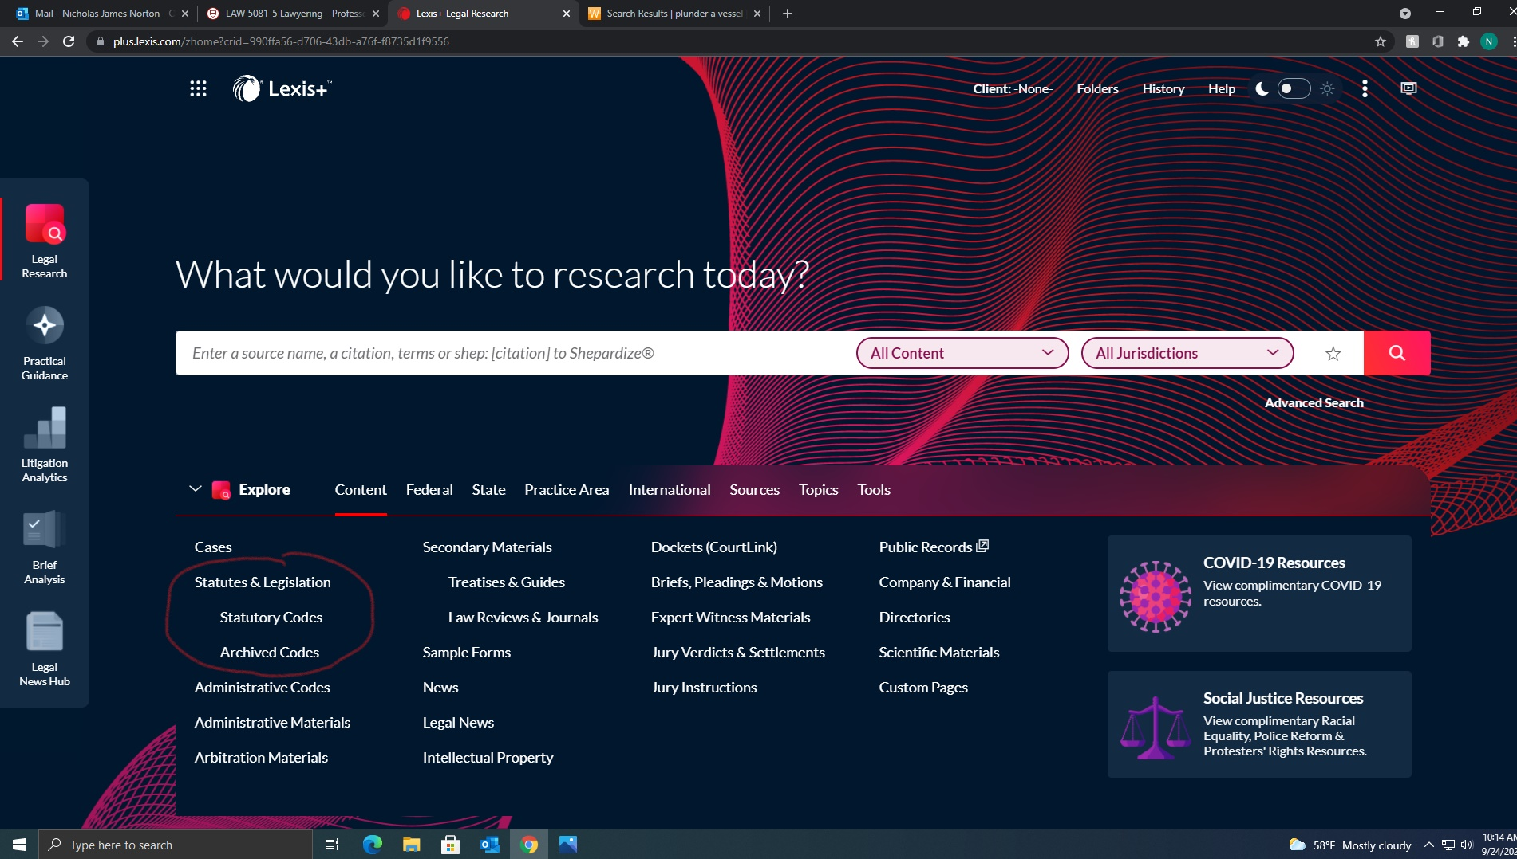

Figure 3. The Lexis+ homepage, with Practical Guidance available to select on the side panel.

2.4 Transactional Precedent Searching

Lawyers use templates all the time to complete their work. A document used in a past transaction is often referred to as a transactional precedent. Why would an attorney need a transactional precedent? While working on an issue, a lawyer wants to save time and resources by using past documents as a starting point. This can be accomplished by using a law firm's internal knowledge management system or form bank. It can also be accomplished by utilizing a form book in print or electronically on Lexis or Westlaw.

Practical Law, Practical Guidance, and Bloomberg Law allow users to search for past documents used by attorneys in past transactions. When looking for precedents, first check with your employer. If there are no relevant precedents within your organization, then check for outside precedents from other transactions or more generic forms. Below is a screenshot of the Bloomberg Law database after searching for “transactional precedent” from the main screen. After locating Practical Law, Practical Guidance, or the transactional precedents section of Bloomberg Law the legal researcher can search by form type, law firm, industry, and more to find relevant transactional precedents. Note that a legal researcher should always consult with their employer to see if there is a form or template applicable to a transaction or matter. For any kind of transaction, it’s always better to start with a template known to work, and modify it to current purposes than re-inventing the wheel for each new transaction.

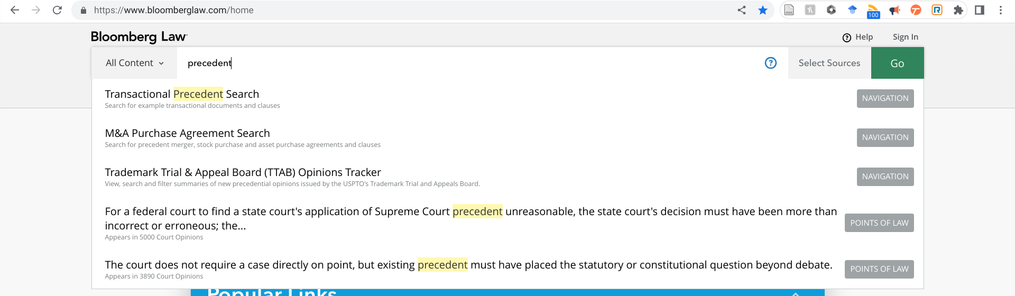
Figure 4. Accessing the transactional precedent search bar on Bloomberg Law

2.5 Application

Suppose that we are researching a standard legal research question and trying to develop a research plan to get started. Read through the problem below and take notes on how you would conduct the research yourself before reading the example answer.

Hypothetical: You run a small law firm in Ithaca, New York. A new client asks for assistance with starting a small business. She just recently completed cosmetology school, and wants to open her own hair salon, but is not sure how to proceed. She retains you as her attorney and asks you to investigate the following questions:

- What does she need to do to set up a small business? Is there any special paperwork she should be aware of?
- Would any business entity choice be more advantageous to her over another?
- Does her cosmetology business qualify as a professional corporation in the state of New York?

Fact Analysis

- Who: client opening a hair salon small business
- Where: Ithaca, NY
- Legal issues: business, property, contracts potentially
- Search terms: [NY cosmetology] [NY hairdresser] [NY small business formation]

Secondary Sources

- Practical Law > New York > Choosing an Entity Comparison Chart
- Practical Law > New York > Toolkits > Corporate Formation & Housekeeping Toolkit / LLC Formation & Housekeeping Toolkit

Government Resources

- https://dos.ny.gov/become-cosmetologist
- https://www.ny.gov/services/start-business-new-york-state
- https://www.cityofithaca.org/179/Business-Assistance

This question calls for offering legal advice on entity formation. Practical Law has a number of resources relevant to this question, but government agency websites also are helpful here, as well. Here, the researcher did an initial fact analysis to identify relevant information, located helpful background materials on Practical Law, before then also checking if government websites offered relevant guidance, as well.

2.6 Concluding Exercises for Chapter 2

Bloomberg Law Transactional Precedent Search Exercise

Your client is a private investment company and is looking to purchase the assets of another company. As their attorneys, they would like you to prepare the following:

- A Confidentiality and Non-Disclosure Agreement
- A Term Sheet
- A Due Diligence Checklist
- An Asset Purchase Agreement

Your boss has asked you to find samples of the above. If possible, locate samples specific to the mining industry.

Law Firm Precedent Searching Exercise

You are a new associate at a large law firm. Your client is doing business with a business represented by Latham & Watkins LLP. To begin to research transactional documents that might be relevant to your work for your client, your supervisor requested the following:
- Litigation analytics information related to Latham & Watkins LLP
- Sample merger & acquisition transactions documents prepared by Latham & Watkins LLP
- An asset purchase agreement where the governing law is Texas prepared by Latham & Watkins LLP

Practical Law & Practical Guidance Exercise

1. Your client is trying to form a corporation in the state of New York. Help them to identify the relevant information they need to complete the formation of the corporation.

- From the Westlaw Practical Law homepage, locate an article on forming and organizing a corporation in the state of New York.
- Now locate a draft articles of incorporation for NY that you could use as a starting template.

2. Your client is trying to form an LLC in the state of Massachusetts. Help them identify the relevant information they need to complete the formation of the LLC.
- From the Lexis Practical Guidance homepage, locate an article on forming an LLC in Massachusetts.
- What statute is relevant to Massachusetts LLCs?
- Locate from the article you found a template for articles of organization for this LLC.

Chapter 3: Publicly Traded Companies

3.1 Learning Objectives for Chapter 3
Reading this chapter will help students understand:
- Different types of company information
  - What is it?
  - Why do you need it?
  - Where do you find it?
- Practice using databases to generate company information reports

3.2 Introduction

Now that we have discussed what legal research for business is and the basics of finding documents for entity formation, let’s next turn our attention to the information that could be useful for a due diligence report. Note that some of the sources highlighted in this chapter require a subscription to access. Check with your employer or a librarian if you are not sure if you have access to a particular database highlighted in this chapter. Many of these tools accomplish the same task (finding and curating relevant content) so you will not need access to every conceivable database to be an effective researcher.

3.3 Finding Company Information

As discussed in chapter one, a lawyer researching business topics likely needs company information. Why might a lawyer need company information? It can be helpful to understand a client and its business to give competent legal advice. Also, it can be helpful to get a competitive advantage – knowing company information very thoroughly can be useful to pitch yourself / firm to get new business. Lawyers often compile this type of background information on corporate clients (or businesses their client might do business with) into reports called due diligence reports. You will have access to different resources in the real world, and you likely will not need to know every conceivable place to find company information.
To locate background information on a publicly traded company (such as number of employees, executives, company history, basic financial data, etc.) a legal researcher may do the following:
- Use the business intelligence center on Bloomberg Law;
- Read company news on Lexis, Bloomberg Law, Google News, or another news aggregator;
- Look up a company using Hoover's company reports on Lexis+;
- Look up a company on the Wall Street Journal company dashboard;
- Find a SWOT report on Business Source Complete or other analyst report;
- Consult filings the company submitted to government entities (State Secretary of State, Federal SEC filings);
- Find company websites that are written for the general public or investors.

Sources such as Hoover’s on Lexis or Bloomberg Law’s business intelligence center can provide the legal researcher with reports covering basic company information. These sources, coupled with the information in public company filings (see chapter five), provide the legal researcher with a great amount of company information. Here are some examples of using legal research databases described above to find company information.

Below is a screenshot of the Bloomberg Law Homepage with the “Business” tab selected. Below that is the Business Intelligence Center. From here, you can enter a company name or stock exchange ticker symbol to look up company information.

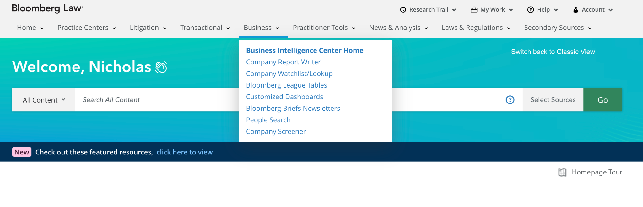
Figure 5. From the homepage of Bloomberg Law, select the business intelligence center to generate a company profile dashboard on a company

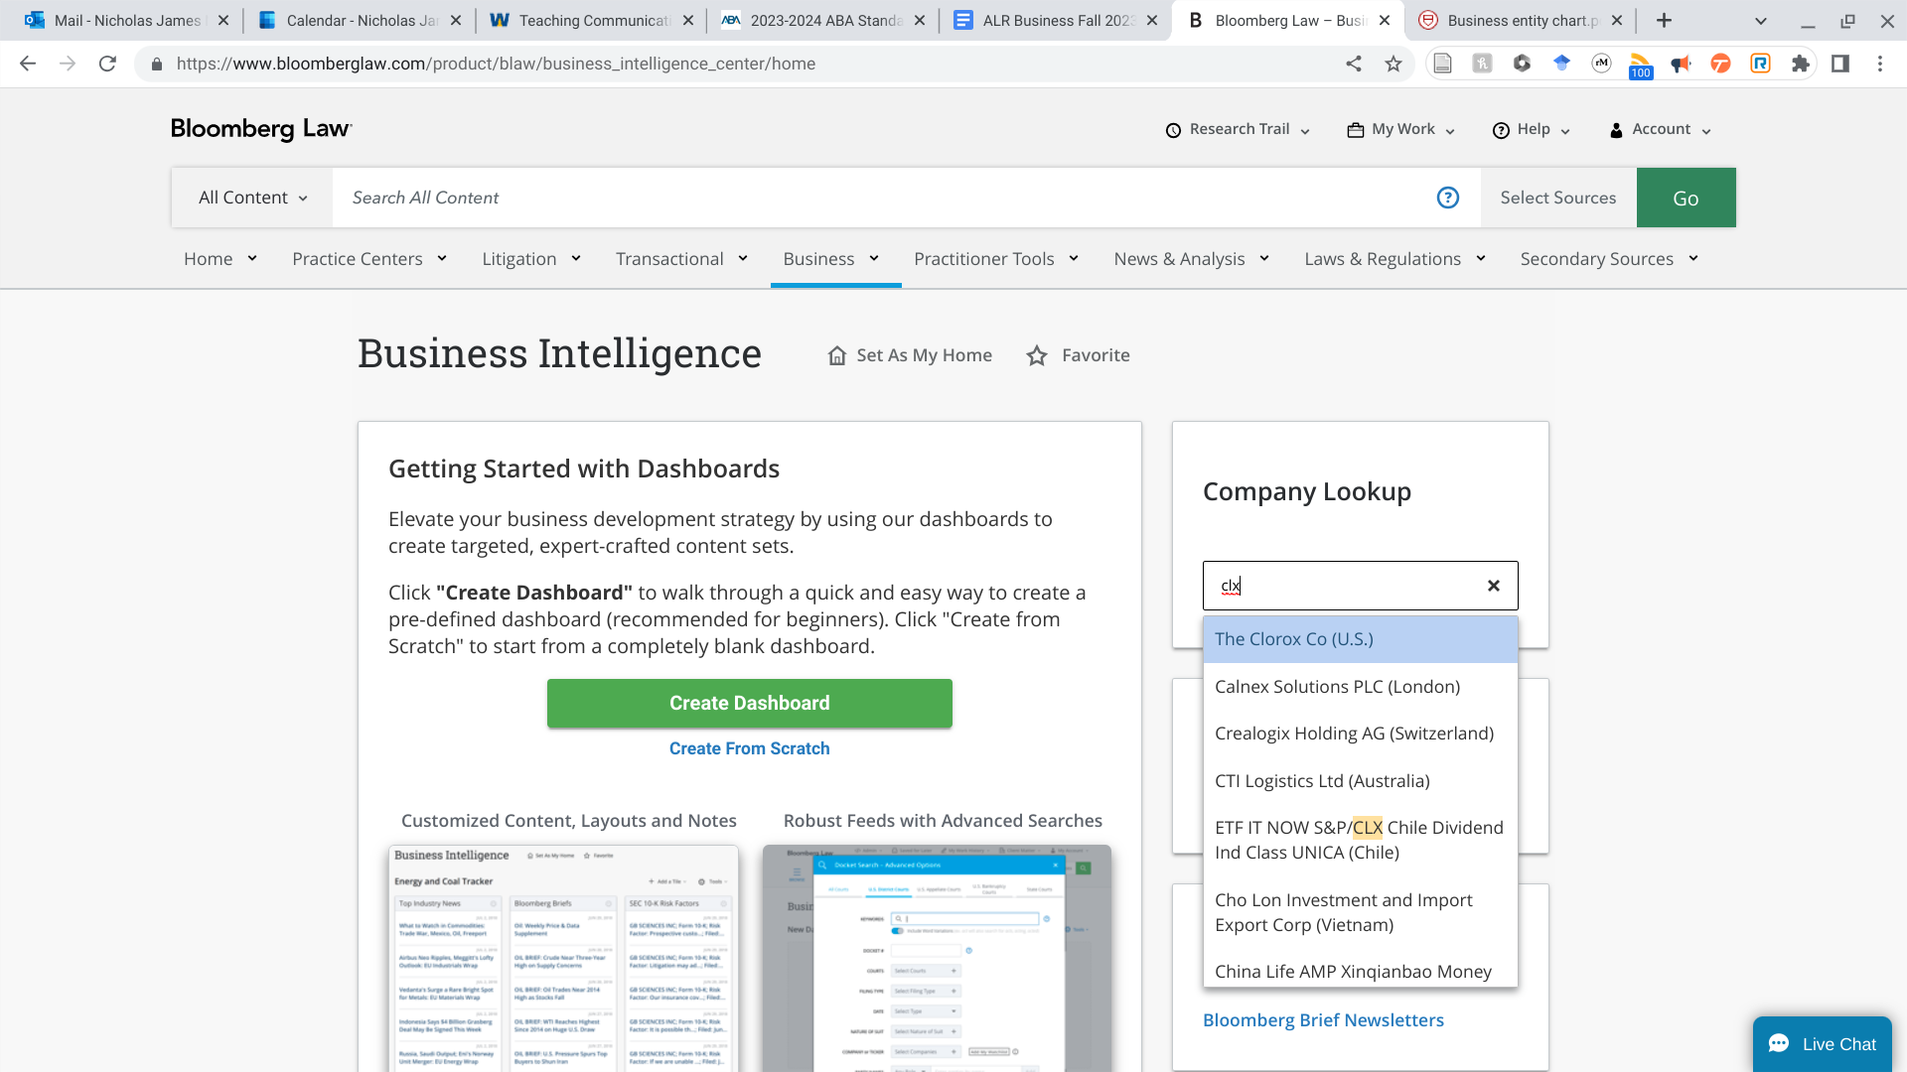
Figure 6. From the business intelligence center the legal researcher can generate
a company profile dashboard by searching for the company by ticker symbol or name

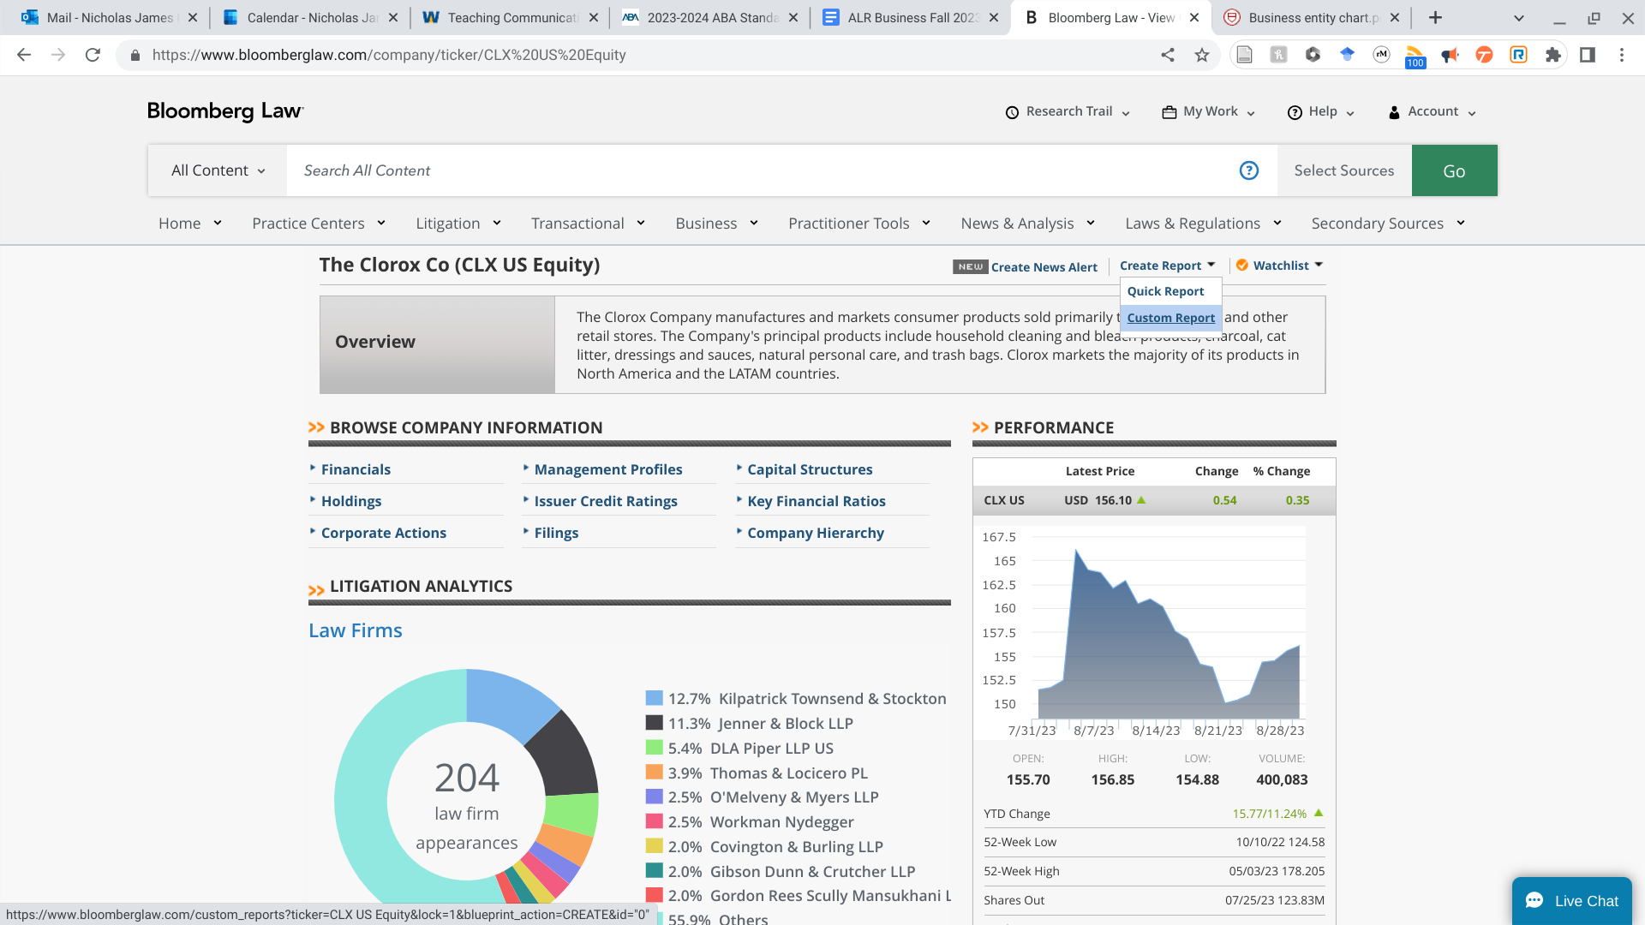
Figure 7. On Bloomberg Law, the legal researcher can generate a
company dashboard to quickly generate a report of company information

Similarly, below are screenshots showing how to get from the main screen of Lexis+, and entering Hoover’s company profiles. From there, information about the Disney company can be accessed with a simple search on the company name.

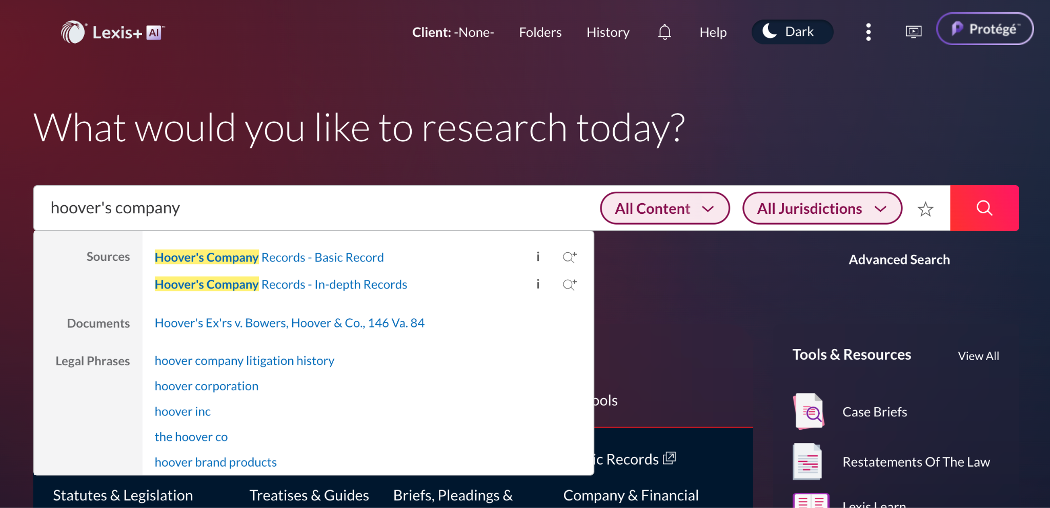
Figure 8. From the homepage of Lexis+, the legal researcher
can go directly into Hoover’s Company Reports to find company information

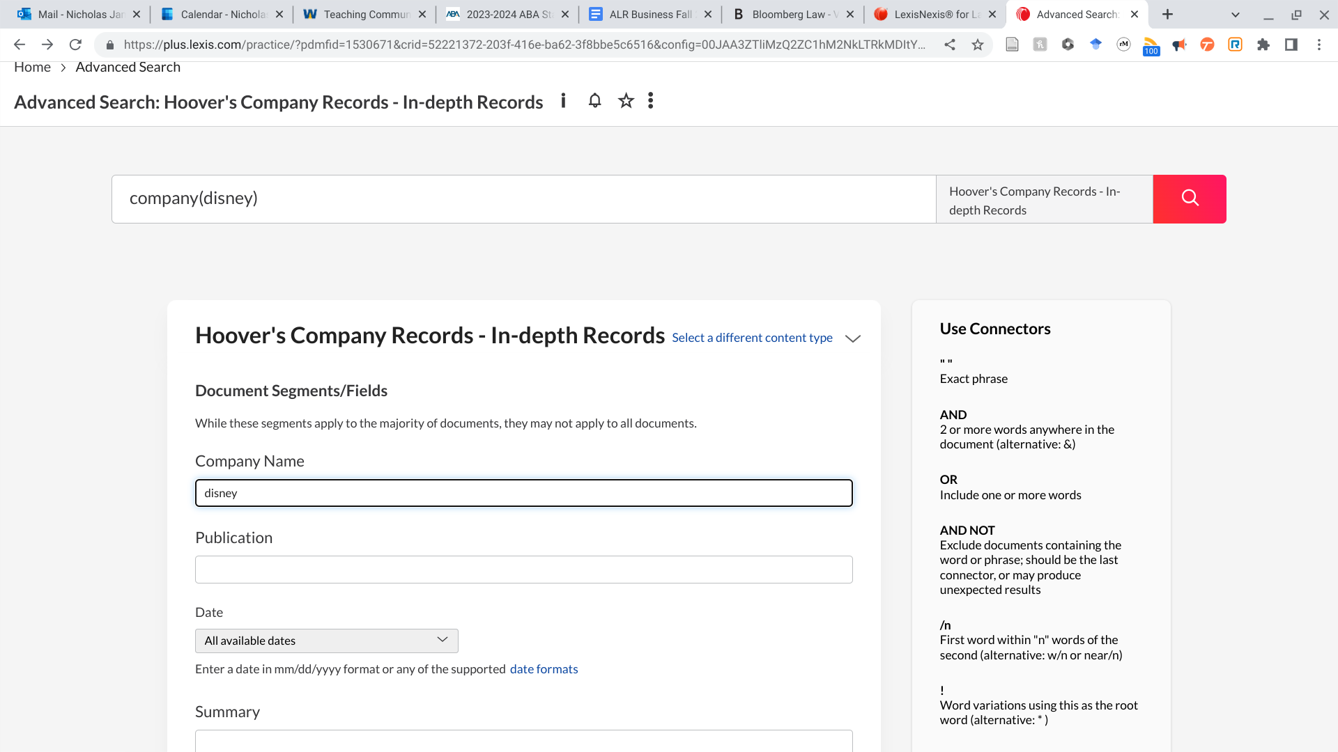
Figure 9 Searching on Lexis+ for a Hoover’s Company Report on the Walt Disney Company
.
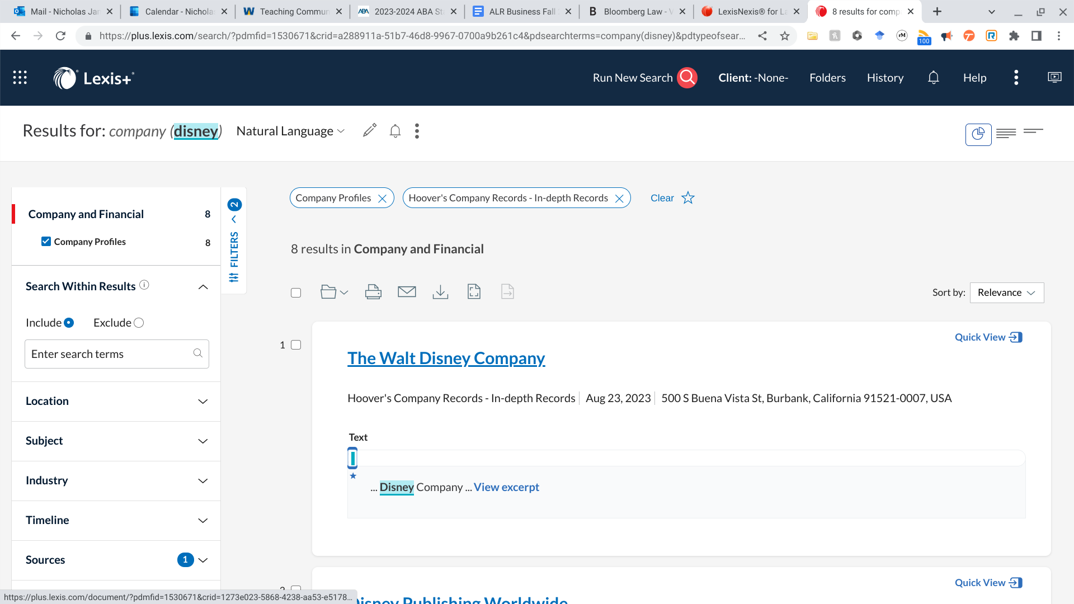
Figure 10. Results on Lexis+ for a Hoover’s Company Report on the Walt Disney Company

Some of the pieces of company information a legal researcher might need will exist on multiple databases and platforms. Consult with your employer to see if there is a preferred place to look for certain pieces of information. If information is primarily being sourced from publicly available documents (like SEC filings) it is wise to check the primary source in addition to any secondary source analysis that cites those documents.
Below is a list of sources that you can consult to find a particular piece of company information. Not every named source is explored in depth in this chapter because the database does an analogous function of another database outlined in this chapter. For databases such as Capital IQ, Bizmier, etc. listed below, consult your employer or librarian to see if you have access to it and if there is any available training or documentation for the platform.

Information | Source
Name of entity | SEC filings, Hoover’s, Bloomberg Law Custom Report, CapIQ, Bizminer, Business Source complete
State of incorporation | SEC filings, Hoover’s, Bloomberg Law Custom Report, CapIQ, Bizminer, Business Source complete
Main office address and contact info | SEC filings, Hoover’s, Bloomberg Law Custom Report, CapIQ, Bizminer, Business Source complete
Current key board members and top officers, including relevant information about them | SEC filings, Hoover’s, Bloomberg Law Custom Report, CapIQ, Bizminer, Business Source complete
Executive compensation for Board Chair and CEO | SEC filings
NAIC and SIC codes | SEC filings, Hoover’s, Bloomberg Law Custom Report, CapIQ, Bizminer, Business Source complete
Discussion of company website | Company website itself
Short corporate history | SEC filings, Hoover’s, Bloomberg Law Custom Report, CapIQ, Bizminer, Business Source complete
Number of employees | SEC filings, Hoover’s, Bloomberg Law Custom Report, CapIQ
Competitors | SEC filings
Stock history over past year | SEC filings, Bloomberg Law, CapIQ,
Relevant SEC filings—what did they report? | SEC website, Bloomberg Law, Lexis, Westlaw
Basic financial information, e.g. annual sales, percent growth, net income | SEC filings, Bloomberg Law Custom Report, CapIQ, Bizminer
Citation and summary of recent news articles and press releases | Lexis+ (Law 360), Google News [“company name” OR “ticker symbol”, for a set time period like last 12 months], Bloomberg Law News, Hoover’s, Factiva, company website
Synopsis of analyst reports/coverage [compare SWOT to SEC filings in terms of strengths and weaknesses of company] | Lexis, Business Source complete
Litigation / regulatory oversight | SEC filings, litigation analytics tools (Westlaw, Lexis, Bloomberg Law)
Chart summarizing where company information can be found across multiple sources

3.4 Application

Hypothetical: You are asked to find company background information on the Clorox corporation to discuss with your supervising attorney the following morning. You consult Bloomberg Law and Hoover’s company reports on Lexis+.

Research Process

Start by looking up Clorox using Hoover’s on Lexis+. Then create a company profile for Clorox on Bloomberg Law to review company news information and litigation analytics information. If you have access to Business Source Complete you can also retrieve a SWOT report for the company by searching in the database. After learning about the company by reviewing this information, a relevant regulatory agency that might have more information relevant information could include the Environmental Protection Agency.

Sample Research Results

- Company name: Clorox
- State of incorporation: Delaware
- Industry
  - Household Products/Wares
  - Industry Sub-Group Consumer Products-Misc
- Short corporate history
  - The Clorox Company is a leading multinational manufacturer and marketer of consumer and professional products.
  - Known first as the Electro-Alkaline Company, The Clorox Company was founded in 1913 by five Oakland, California, investors who put up $100 apiece to make bleach using water from salt ponds around San Francisco Bay.
  - Its products are sold primarily through mass retailers; grocery outlets; warehouse clubs; dollar stores; home hardware centers; drug, pet and military stores; third-party and owned e-commerce channels; and distributors.
  - The company's revenue for fiscal 2021 was $7.1 billion. [Hoover’s]
- Competition overview
  - Clorox faces stiff competition from consumer product companies both in the US and in its international markets. The majority of the company's products compete with other broadly advertised brands within each product category. Clorox competes with retailers, including club stores, groceries, dollar stores, mass merchandisers and internet-based retailers, which are increasingly offering private label brands that are sold at lower prices and compete with the company's products in certain categories. Clorox's products generally compete based on product performance, brand recognition, price, advertising, promotion, merchandising and packaging.
  - Some of the company’s competitors are P&G, Unilever, Church & Dwight, WD-40, and Reckitt Benckiser Group, among others. Some of these competitors are larger and have greater financial resources as compared to the company. They can also spend huge resources on advertising and promotional activities, and are able to react more efficiently to varying business and economic conditions than Clorox. Additionally, if the company's competitors offer lower-priced products, Clorox could lose its market share to its competitors. Any such decline in sales volumes could prompt the company to focus on its lower margin products. [Business Source complete marketline SWOT]
- Litigation overview / example
  - Clorox Co. was hit with a proposed class suit alleging it failed to disclose that some of its Pine-Sol branded cleaning products could contain bacteria, days after the company issued a recall
  - The popular cleaners could contain Pseudomonas aeruginosa bacteria, which can lead to life-threatening infection, New Yorker Charles Scandore alleges in a suit filed Thursday in the US District Court for the Eastern District of New York. [Bloomberg Law News https://news.Bloomberg Lawlaw.com/health-law-and-business/clorox-pine-sol-recall-followed-by-consumer-deception-lawsuit]
- Regulation overview / example
  - Example would include EPA regulation of pesticides in cleaning products https://www.epa.gov/pesticide-registration/determining-if-cleaning-product-pesticide-under-fifra

3.5 Exercises for Chapter 3

Company Information Exercise
1. You are a new associate at a law firm and asked to assist with the formation of a corporation. Unfortunately, you didn't take corporations in law school and know nothing about corporate law. What would be a good source for you to skim to get up to speed?
- Case law
- American Jurisprudence
- Wikipedia
- Hoover's company reports

2. Going to the source you identified in the previous question, what would be a good section to read in order to understand the basics of articles of incorporation?

3. You are an associate at a large law firm doing business with the Walt Disney Corporation. Your supervisor asks you to prepare a memo with background information on Disney as a company. What source would be a good place to start?
- Case law
- American jurisprudence
- Wikipedia
- Hoover's company reports

4. Going to the source you identified in the previous question, write a 3 to 5 sentence summary of the company's history (where was it founded, what does it do now). Include a cite or link to the source used.

5. Now pull up Walt Disney Corporations profile on Bloomberg Law's business intelligence center. Download a custom report on the corporation. What information is more in depth on this report than the source from the previous question? What information is less in depth?

Chapter 4: Administrative Law Legal Research for Business

4.1 Learning Objectives for Chapter 4

Reading this chapter will help students understand:

- What regulatory agencies are relevant for researching publicly traded companies;
- Practice using the SEC EDGAR database & Bloomberg Law database.

4.2 Introduction

Chapter three laid the groundwork for understanding company information and the sources to locate that information. Among these sources, the Securities and Exchange Commission (SEC) was mentioned as one source among many to find company data. Building upon that introduction, this chapter delves deeper into the realm of the SEC, providing essential background on its role and the filings companies produce for that agency. We will explore why SEC filings stand as such a rich and invaluable repository of company intelligence. Furthermore, this chapter will introduce how to research other regulatory agencies that may hold pertinent information for business research.

4.3 The Securities & Exchange Commission

SEC filings were mentioned in the last chapter as a particularly valuable source of company information for publicly traded companies. How did the SEC come to be? According to the Congressional Research Service:

Congress passed the Securities Exchange Act of 1934 (P.L. 73-291) to create the Securities and Exchange Commission (SEC) in the wake of the stock market crash in 1929 to help restore confidence in capital markets. The SEC is an independent federal regulatory agency responsible for administering federal securities laws. It has broad regulatory authority over significant parts of the securities industry, including securities offering and trading, asset management, and investment advisory.

The SEC requires that publicly traded companies file a number of documents with them throughout the year to stay in compliance with federal law. According to Matt Morrison's Due Diligence: Company Information for Law Students:

The two major laws that govern company communication to the government and the investing public are the Securities Act of 193347 (’33 Act), and the Securities Exchange Act of 193448 (’34 Act), and concomitant regulations codified at title 17 of the Code of Federal Regulations (C.F.R.). The overriding purpose of these laws is disclosure. The ’33 Act regulates the registration of public offerings. The ’34 Act seeks integrity in the markets via periodic reporting to the SEC and solicitation of proxies.51 The ’34 Act also includes registration requirements.
...
As noted earlier, periodic reporting is required under the ’34 Act. The three main periodic reporting forms are the 10-K, the 8-K, and the 10-Q. The 10-K is the annual report, including audited financials, and there are rules on the timing of the filing. The 8-K, which keeps investors up-to-date, is for interim reporting—events that occur between reporting periods are filed on this form. The 10-Q is for quarterly reports and is filed three times per year. A disclosure similar to periodic reporting is the proxy statement. Proxies disclose information specifically to shareholders. This serves shareholder suffrage—shareholders need appropriate information to make informed decisions on how their shares will be voted at a company annual meeting. Proxy disclosure requirements are governed by Regulation 14A. Need-to- know information includes how terms are defined and what information must be included in documents used for proxy solicitations. Moreover, filers must be aware of Schedule 14A. This extensive schedule lays out what companies must provide in the proxy statement. Specific items are presented, and these include matters to be acted on, executive compensation, and financial information.

Legal researchers investigating a publicly traded company should always check for documents filed with the SEC. SEC forms filed by companies contain a wealth of company information. This includes but is not limited to:

- Financial information
- Analysis of the company’s current financial condition
- Executive compensation
- Significant risks a company faces
- Ongoing pending litigation

Locating forms filed by a company to the SEC is relatively straightforward using the SEC’s EDGAR database. A legal researcher can also search the EDGAR database using Bloomberg Law. Below is the EDGAR interface for searching company information. Note that the stock exchange ticker abbreviation “CLX” was entered as a search for the Clorox company. The second image shows the main results page for Clorox. A user can now click on the links for the various filings they want to review and see the documents.

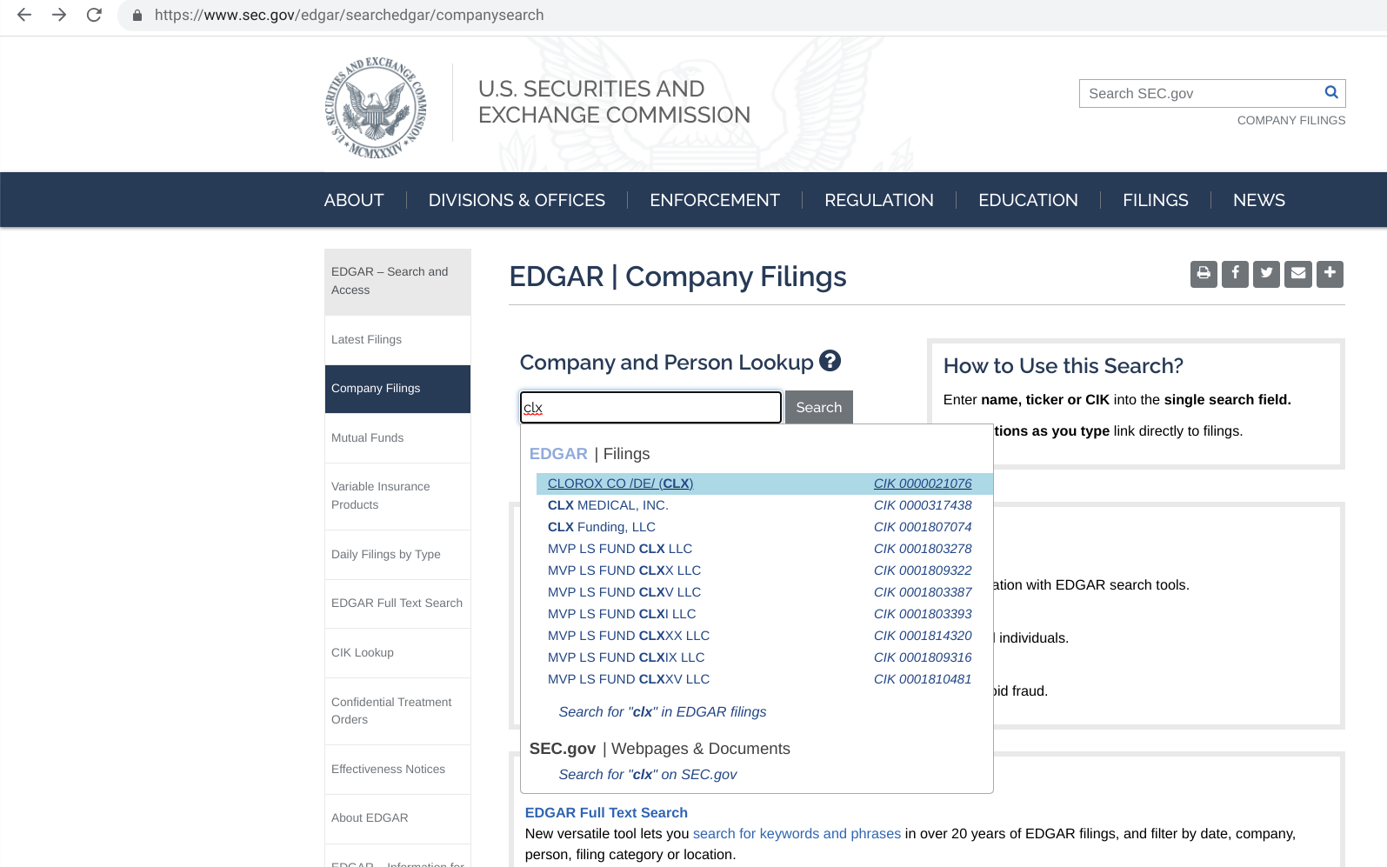
Figure 11. The EDGAR Database to retrieve up SEC Filings on publicly traded companies.

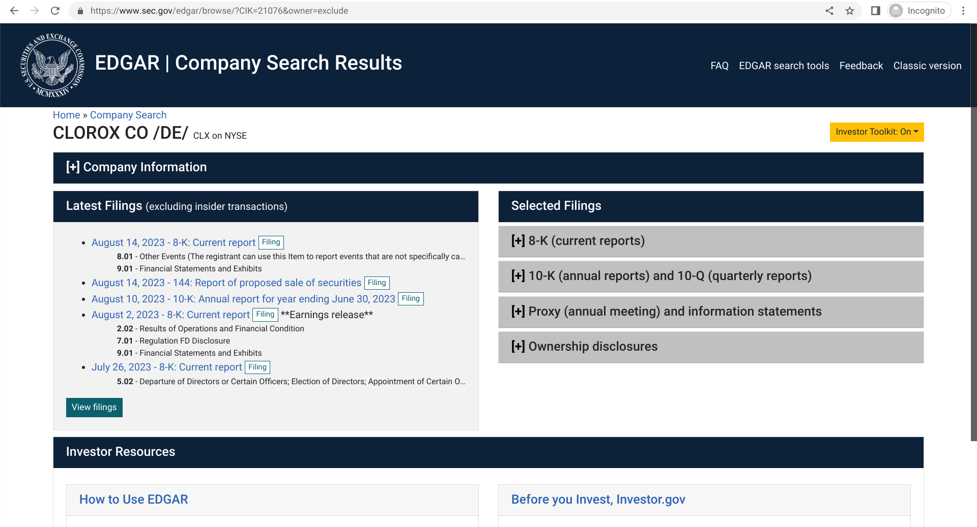
Figure 12. The EDGAR Database results for Clorox.

Below is a similar result using the SEC filings search in Bloomberg Law. Bloomberg Law and other databases source their data from the SEC EDGAR database. This means that if you are more familiar with one particular database (such as Bloomberg Law, Lexis+, or Westlaw) you may be able to conveniently access SEC filings on that database alone.

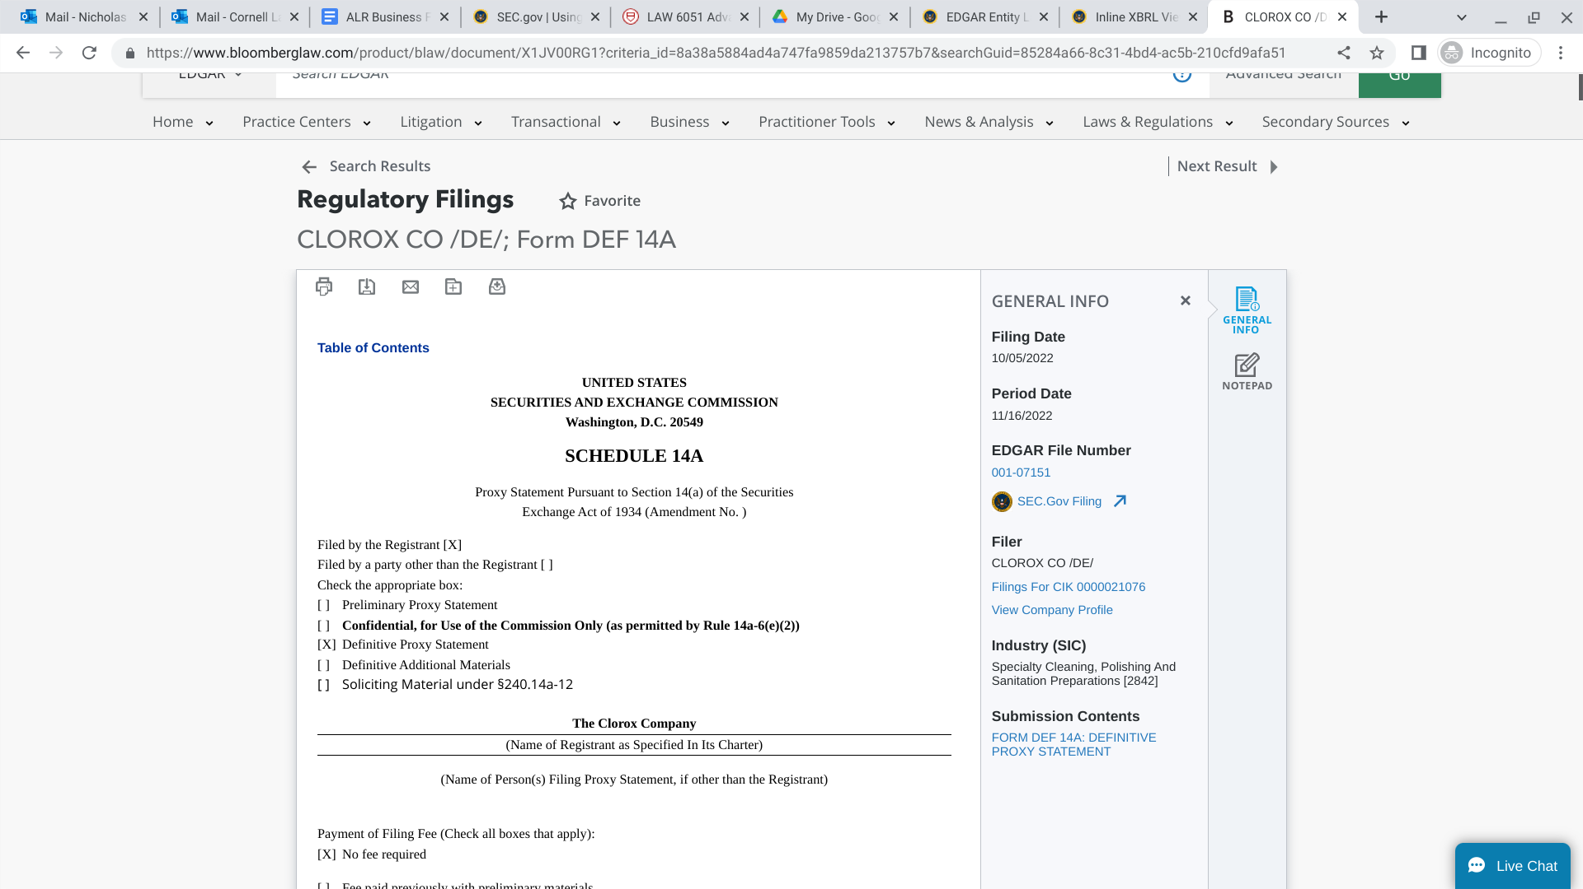
Figure 13. Result for SEC filings search on Bloomberg Law

4.4 Non-SEC Regulatory Agency Research

When researching a particular company, it is helpful to get a full picture of the various entities that regulate the conduct of that entity. For example, in addition to filing requirements from the SEC, Exxon Mobile must comply with various regulations promulgated by the Environmental Protection Agency. For purposes of administrative law research as it impacts a company the following would be useful to keep in mind to get started:

- What agencies impact the activities of this company?
- What specific regulations impact the activities of this company?
- Is your company involved in litigation related to any regulatory issues?
- Is your company trying to change regulations from one standard to another?
- What secondary content (Practical Law, Practical Guidance, treatises, etc.) would be helpful to get up to speed on this area of law?

The regulations relevant to a company will also likely be detailed in the filings a company provides to the SEC, as well. For example, Clorox in their 2024 10-K SEC filing detailed:

Generally, the manufacture, processing, formulation, packaging, labeling, storage, distribution, advertising and sale of the Company’s products and its business operations must comply with extensive federal, state and foreign laws and regulations, including, in the U.S., the Environmental Protection Agency, the Food and Drug Administration (including applicable current good manufacturing practice regulations), the Consumer Product Safety Commission, the Federal Trade Commission, and the Occupational Safety and Health Administration. (Emphasis added)

Once you have identified the relevant administrative authorities that are pertinent to the company you are researching, you can target your research to those specific agencies. The major legal research platforms all have an administrative materials section of their database curating this type of content. Fully exploring all of that content is beyond the scope of this book, but if you need assistance locating materials concerning a particular agency, consult with your employer or a librarian.

4.5 Application

Hypothetical: Practice Reading and Prepping 10-K
You are a new lawyer in McDonald’s general counsel’s office. Find the company’s most recently filed annual report (10-K) filed with the SEC. Your supervisor asks you to compile a list of what information will be needed for this year’s annual 10-K filing. Write an email outlining what information is needed.

An answer to this question could include references to the following sources such as:

- SEC Investor Bulletin: How to Read a 10-K https://www.sec.gov/files/reada10k.pdf
- Investor.gov, How to Read a 10-K https://www.investor.gov/introduction-investing/getting-started/researching-investments/how-read-10-k
- Harvard Business School: How to Quickly & Efficiently Read an Annual Report https://online.hbs.edu/blog/post/how-to-read-an-annual-report

4.6 Concluding Exercises for Chapter 4

SEC Forms Exercise
You are a new employee in the McDonald’s general counsel office. Review the company’s latest 10-K, 10-Q, and 8-K filed with the SEC. Use the forms to see how much of the information below you can locate. Prepare a brief written summary.

Requested Information | Answer
Name of entity
State of incorporation
Main office address and contact info
Current key board members and top officers, including relevant information about them
Executive compensation for Board Chair and CEO
Short corporate history
Number of employees
Competitors
Stock history over past year
Basic financial information, e.g. annual sales, percent growth, net income

Chapter 5: Privately Held Companies

5.1 Learning Objectives for Chapter 5

Reading this chapter will help students understand:

- The difference between publicly traded and privately held companies
- Compare company profiles for various public and private entities
- Practice using Bloomberg Law and other databases to research privately held companies

5.2 Introduction

In the previous chapters we have explored company information and the sources relevant to finding it, including public information found through government agencies such as the SEC. Not all companies, however, are publicly traded on a stock exchange. Some are small businesses or large corporations that are privately owned and thus do not have to file the same information with government regulators as a publicly held company. This impacts the amount of information that will be publicly available to a researcher investigating these companies. This chapter will explore some approaches to researching a privately held company.

5.3 Privately Held Companies

In Chapter Four you learned about the Securities and Exchange Commission and the various forms required to be filed by publicly traded companies. You may have been wondering if these same filing requirements apply to privately held companies. The answer is no, privately held companies are not required to file reports and filings with the SEC. Privately held companies are under (as you might expect) private ownership. Many companies chose to become public primarily to raise capital. However, while a privately held company might find it harder to raise capital, it is also not subject to nearly as much regulatory paperwork as a public company. The owner of a private company, however, may be held liable for their company’s debts and obligations.

The legal researcher will not have easy access to public data (like that found in SEC forms) to conduct research on a privately held company. All hope is not lost, however. There are still a number of research strategies to deploy when investigating these private firms. Consider the following:

- Identify what information you already have access to & identify gaps compared to a publicly traded company.
  - Check company profiles on Bloomberg Law, Hoover’s, etc. if they exist for this privately held company.
  - Check in litigation analytics to see if there are recent or historical cases that might have produced discovery / useful information. You can search by a particular company name in the litigation analytics content section of the major legal research platforms.
  - You are likely going to have less financial information.
  - You are likely going to have less background information on the management of the company.
- Visit the company’s website and social media if they exist. Note any contact information (emails, phone numbers, etc.). If you find any names of individuals leading the organization, you may also be able to search for employees or managers of this company on LinkedIn to find more about their background.
- Pull up the company on the state agency responsible for the company’s registration. This will typically be the Secretary of State for that state. It may also be a regulatory agency that oversees the company’s industry. Review any documents filed with that state regulatory agency. Google the relevant state name and “business entity search” to find out what the online database for that jurisdiction will look like.
- Conduct a news search on the company to see if any journalistic publication has written or investigated this company before (note you may need to check local news sources not just major publications).
- See if scholarly or popular nonfiction books by journalists exist that cover the company in any depth.

5.4 Application
One private company you may have heard of is Koch Industries, which has been privately held since its founding in 1940. Using the five steps outlined in the previous section, practice locating information on Koch Industries. Then compare your findings with the results below.
Below is an example outline of what type of information a legal researcher could begin to find on a privately held company. We start first by pulling up what information we do have. This is done through searching the company on databases such as Bloomberg Law and Lexis+ as we have done in previous chapters. Then we gather publicly available information like company websites and social media accounts that you can find by Googling the company. Then visit the state business entity database for the state where that privately held corporation is incorporated and search for the company by its name. Then we will search news aggregators for company news information (for more on finding company news information, see chapter six). Finally, you can search Google Books or consult a librarian to see if there are any scholarly books written on the company that would be useful.
Koch Industries
- What information do we have?
  - https://www.Bloomberg Lawlaw.com/company/ticker/3097Z%20US%20Equity
  - https://plus.lexis.com/api/permalink/feca1845-d14a-4abf-8540-7c7027ad32b7/?context=1530671
- Company website
  - https://www.kochind.com/
  - https://www.facebook.com/KochIndustries
- Company registration with state agency
  - https://www.kansas.gov/bess/flow/main?execution=e1s5
- News search
  - https://news.google.com/topics/CAAqIggKIhxDQkFTRHdvSkwyMHZNREZqT0RScUVnSmxiaWdBUAE?ceid=US:en&oc=3
  - https://plus.lexis.com/api/permalink/4a6edf59-95f6-49b9-adc7-438e87a93cd0/?context=1530671
- Scholarly books
  - Leonard, Christopher. Kochland: The Secret History of Koch Industries and Corporate Power in America. India, Simon & Schuster, 2020.
  - Koch, Charles. Continually Transforming Koch Industries Through Virtuous Cycles of Mutual Benefit. N.p., Koch Industries, 2020.
  - Schulman, Daniel. Sons of Wichita: How the Koch Brothers Became America's Most Powerful and Private Dynasty. United States, Grand Central Publishing, 2014.

This is not as much information as a researcher would when investigating a public company, but it is still a good amount of information. The major thing to keep in mind when thinking through private company research is how to obtain information in alternative ways. If publicly available documents like court records are not helpful for researching one private company, news publications might be. This type of research requires a bit more creative thinking, but in many ways that makes it all the more fun.

5.5 Concluding Exercises for Chapter 5

- Visit the Bloomberg Law Company profile for Cargill Inc. List a law firm that has represented this company according to the litigation analytics chart.
- Download a Bloomberg Law Custom Report on Cargill Inc. with as much detail as it can provide. On the most recent litigation page, what is a recent case involving this company that is listed?
- What is the company website for Cargill Inc? List any relevant contact information found on this website.
- Do a search to see if there are any scholarly or journalistic books on Cargill Inc. Cite to one below.
- Visit the google news topic page for Cargill Inc. Link to a recent news article which may be relevant to a due diligence report on the company.

Chapter 6: Company News

6.1 Learning Objectives for Chapter 6

Reading this chapter will help students:

- Understand what company news is and why it is valuable;
- Identify appropriate sources to use as news aggregators to efficiently find company news;
- Create news alerts for company information;
- Practice “getting up to speed” on a company by creating a digest of company news.

6.2 Introduction

When conducting company research, a variety of primary sources are very useful – SEC filings and lawsuits are valuable sources of insight into a company's workings. Equally important, however, are secondary sources. News media, both national and local, write about the business activities every day. Often, the media is able to uncover stories about a company that is of great concern to the general public and of great consequence to the company. Why should a legal researcher stay on top of company news? There are several reasons. First, staying current on business trends in a particular industry will inform what compliance or regulatory issues might be relevant to a business lawyer’s future work. Second, if a lawyer is advertising services to a particular company, it helps to know what recent activities that company has undertaken. Finally, as a part of a due diligence investigation, the researcher should dig deep into what the news coverage of a business entity has been historically. Was there a significant scandal a decade ago? Did the company have to change a notable policy because of harsh media coverage? These questions and more are uncovered by diving into news coverage of the company.

6.3 Sources for Staying Current

Legal research databases like Lexis+ and Westlaw both have general news as well as legal news sources. To research a company’s media coverage on Lexis or Westlaw, select a news source from the list of sources below the search bar. Then consider searching for the name of the company in quotation marks in popular media publications. An example could be searching “Clorox” in major publications such as the Wall Street Journal or New York Times to find recent news coverage of the company. If you are researching a smaller company, consider seeing if a local newspaper where the company is based out of has written about the business. Once you have a search term or parameter that you like on a research database, they will often allow you to set up alerts to receive email updates at regular intervals. Each of the major legal research platforms also have features allowing the researcher to set up search alerts on company news.

If you do not have access to a major research database with vast amounts of news information through your employer, visit your local library as you may have access to news sources through any databases they subscribe to. You can also utilize Google News to retrieve news content and create alerts. Below is an example of creating a topic on Google News for the Clorox Company where the user could then set up custom alerts.

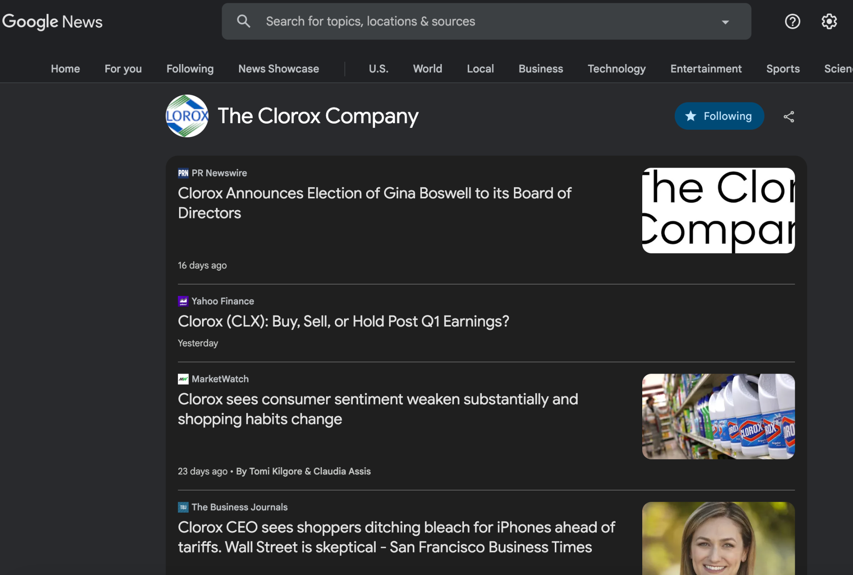
Figure 14. An example of the Google News interface

Below is the Bloomberg Law screen for Clorox Co. in the background, with the “Create Search Alert” popup screen in the foreground. Using tools like this, it is easy to keep up to date. Below the Bloomberg Law image, there is a screenshot of where to go in Lexis+ to get news. Finally, there is a company news dashboard page from the Wall Street Journal.

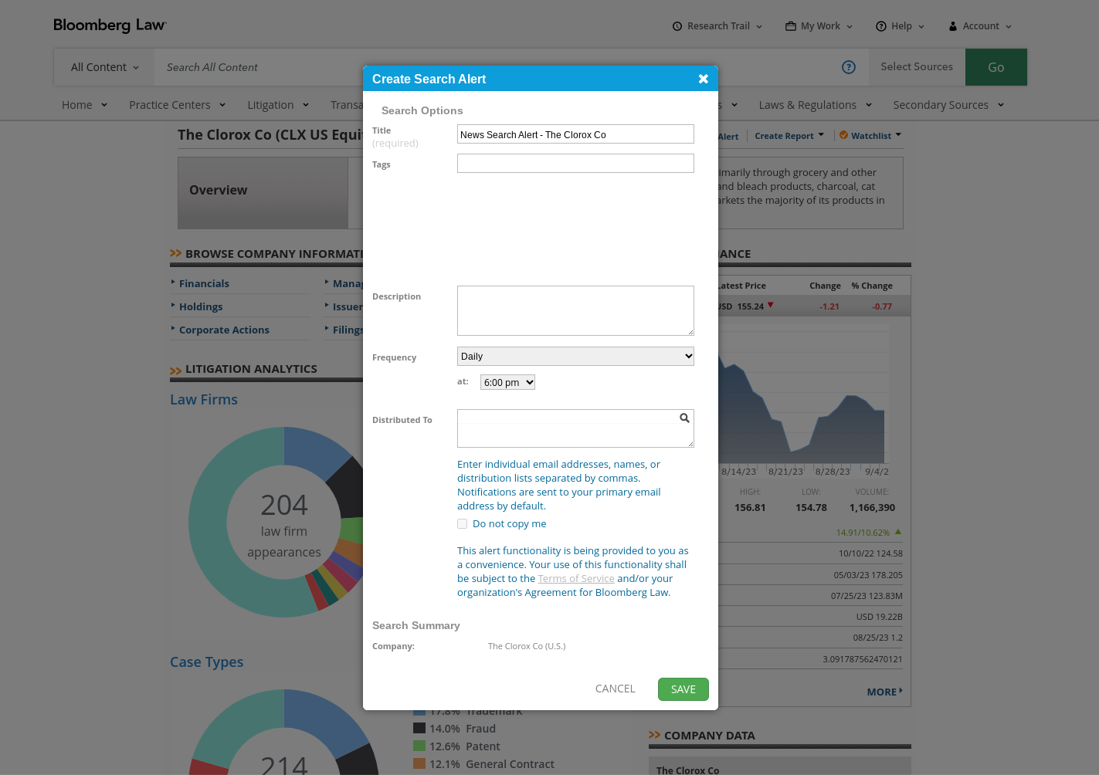
Figure 15. An example of creating a news alert from a company dashboard on Bloomberg Law

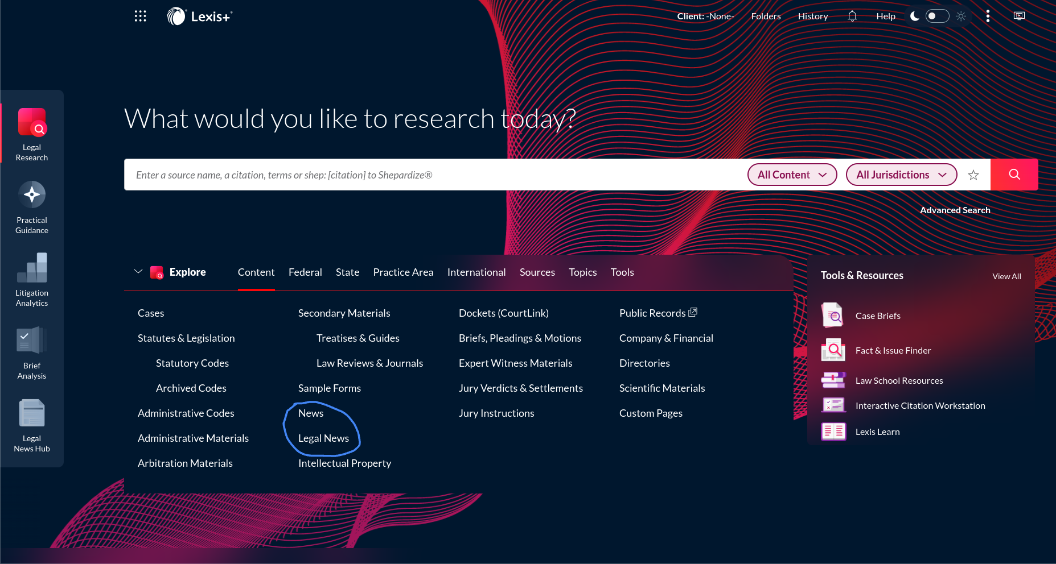
Figure 16. From the Lexis+ homepage, select news or legal news
to then select media sources relevant to researching a particular company

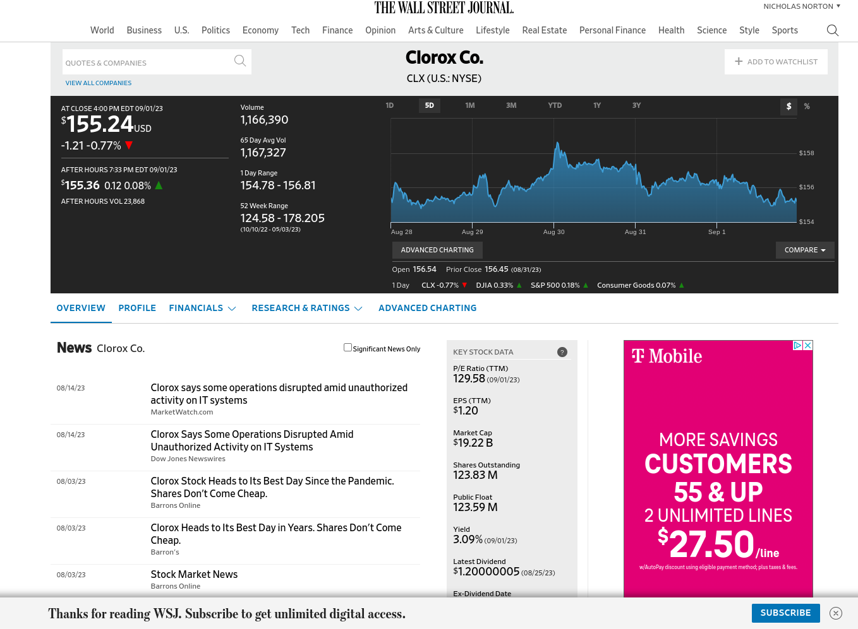
Figure 17. The Wall Street Journal website can create a dashboard of a company, as well,
that is useful for tracking valuable company news and updates

6.4 Writing About Company News

When writing about news for a research report like a due diligence report, formatting is key and should be consistent. Follow whatever is the custom of your employer in the future, but one possible format for news write ups for reports are:

Title of Article in Bold (Or One Sentence Summary of Article). Paragraph of three to five sentences summarizing the article. This should include the key takeaways from the article (who, what, when, where, why, how, etc.). Make it a brief and concise summary of the relevant piece of company news. [Date of article in mm/dd/yy, Source with hyperlink]

Example:
Brita Overhypes Devices' Water Filtering Abilities, Suit Says. The Brita Products Co. was hit with a proposed class action in California state court by a customer who accused it of overstating the ability of its water filtration devices to remove and reduce hazardous contaminants below lab detection limits. In a complaint filed Wednesday, Los Angeles County resident Nicholas Brown accused Brita, owned by the Clorox Co., of violating several Golden State consumer protection statutes by overhyping the ability of some of its water treatment filtration devices, which come as dispensers or pitchers. The products at issue are Brita-brand Standard Water Filters, Stream Filters and Elite/Longlast Filters, including compatible Brita dispensers and pitchers. [Law360, 08/16/23]

6.5 Application

Hypothetical: Imagine that you are asked to write a report on recent company news on Clorox Co. Find recent articles on the company and ask an AI tool (such as ChatGPT, Gemini, or one of the AI tools available on a legal research database) to summarize the news articles for you. Then read through the article yourself. Evaluate the following:

- Did the AI tool provide an accurate summary of the news article?
- If it did, was relevant information omitted from the summary?

6.6 Concluding Exercises for Chapter 6

Visit Google News and search for articles on the Walt Disney Corporation. Locate three articles concerning recent regulations of a corporate activity Disney is undertaking in a sector of their business. Write a short paragraph that could go into a due diligence report summarizing this news item. Next, set up a news alert on a Lexis+, Google News, and Bloomberg Law for Walt Disney Corporation. Discuss with a neighbor what search terms make an effective news alert.

Chapter 7: Campaign Finance Research

7.1 Learning Objectives for Chapter 7

Reading this chapter will help students understand:

- How public and privately held companies influence the political process;
- Where to find federal and state level campaign finance information;
- Practice researching the campaign finance information on a political candidate and company.

7.2 Introduction

As was discussed in previous chapters, doing legal research for business can look different depending on the context. Advising about starting a small business (entity formation covered in chapter two) is different work than advising a corporation about filing a 10-K (SEC filings covered in chapters three and four). So, too is the idea of researching a company as a government regulator yourself. Suppose you are researching a company to assist a legislator investigate a company’s impact on a particular industry. Or you are assisting a company with lobbying government officials to change a law in your clients favor. These are examples of doing research that has an intersection with the political process. Thus, this chapter will go over some of the common places to look for company information in regards to campaign finance if that is a relevant dimension you need to research on a particular company or industry.

7.3 Campaign Finance Basics
Public and privately held companies often influence the political process. For example, Harvard Business Review has described how:
[Corporations] contribute to the campaigns of elected officials, lobby regulatory agencies, and do what they can to influence the selection of judges. The result is a system in which the businesses themselves are often the ones who make the rules in the first place. When businesses write the rules, bad things happen. Companies can manipulate regulations to hinder their competitors. They can grant themselves tax breaks or boost their profits at the expense of public safety and the environment. Economists use terms like ‘rent seeking’ or ‘state capture’ but whatever we call them, these corporate behaviors erode faith in government and the democratic process.
Legal research for business can intersect with corporate political activity in a number of ways. A lawyer may be advising a company on how to properly lobby a state government. A lawyer might advise a government official on how regulations exist on corporate political activity and how they could be reformed. A legal researcher may wish to see how a company has influenced a particular issue over time. The researcher can find this campaign finance data by visiting both the Federal Election Commission’s website and various state and local government campaign finance databases. By looking up individual politicians the legal researcher can compile donations that a company has made to a particular government leader.
Below is a screenshot of the Federal Election Commission website where anyone can easily look up the donations a company has made to political campaigns. Next is an example of results from looking up federal donations to a particular political action committee. Finally, there is a screenshot of doing a campaign finance search for the state of New York. Note that depending on the type of election or donation being researched, the researcher may have to check federal, state, or even local county / municipality databases.
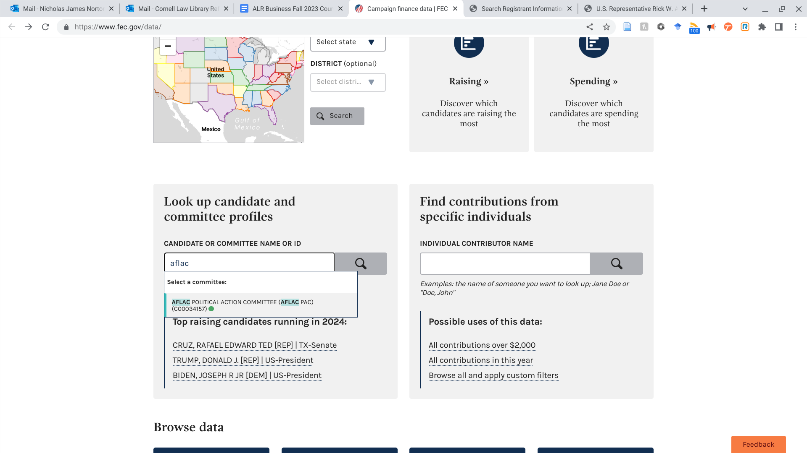
Figure 18. An example search on the Federal Election Commission website to find campaign donations by a corporate political action committee

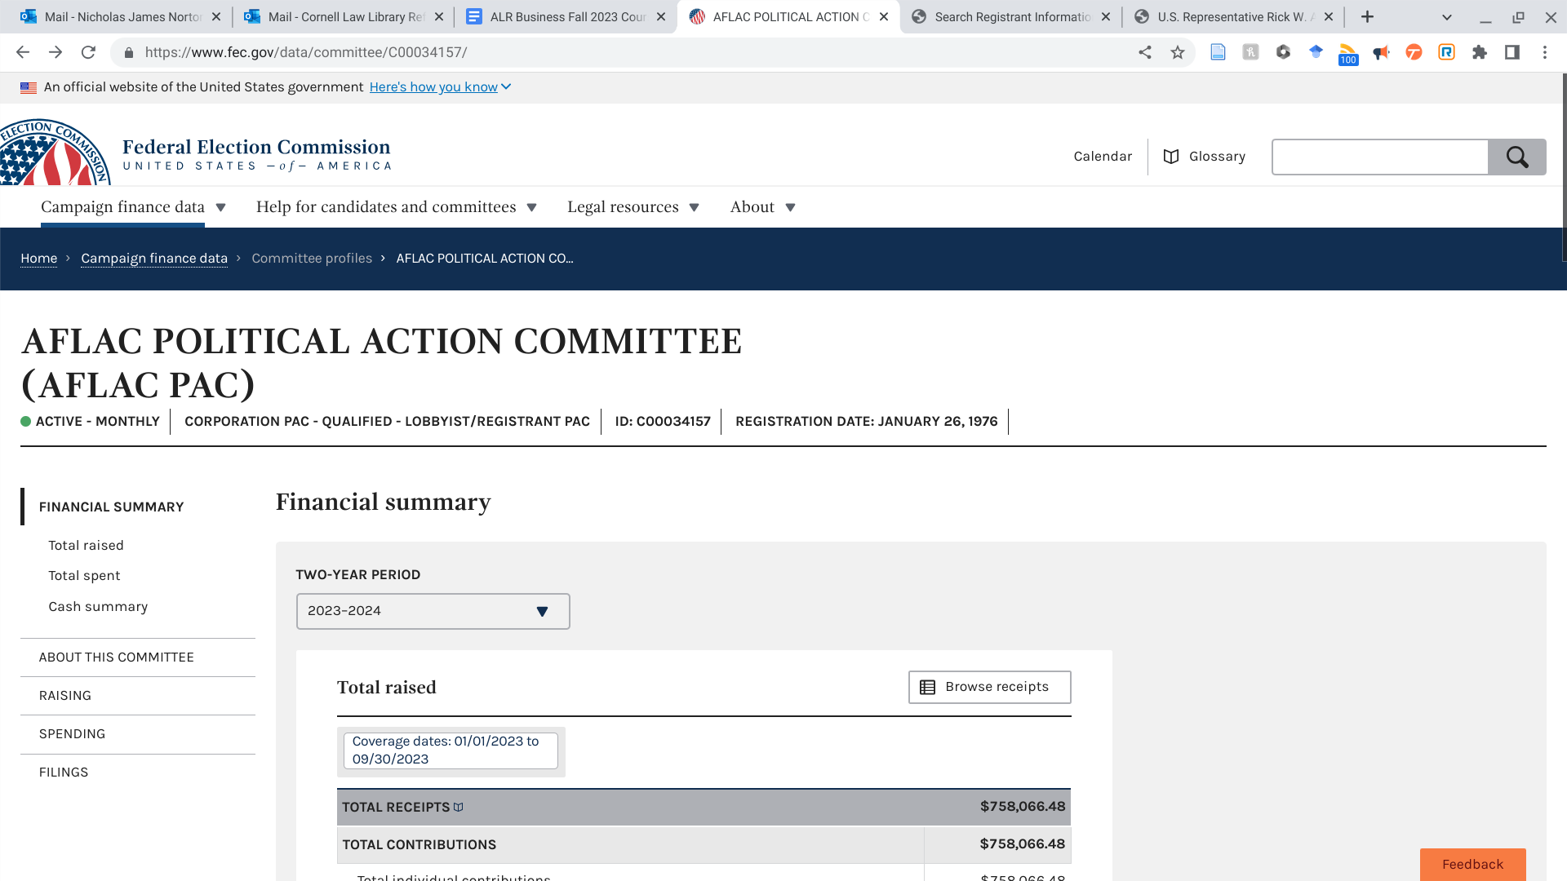
Figure 19. Example results on the Federal Election Commission website to find campaign donations by a corporate political action committee

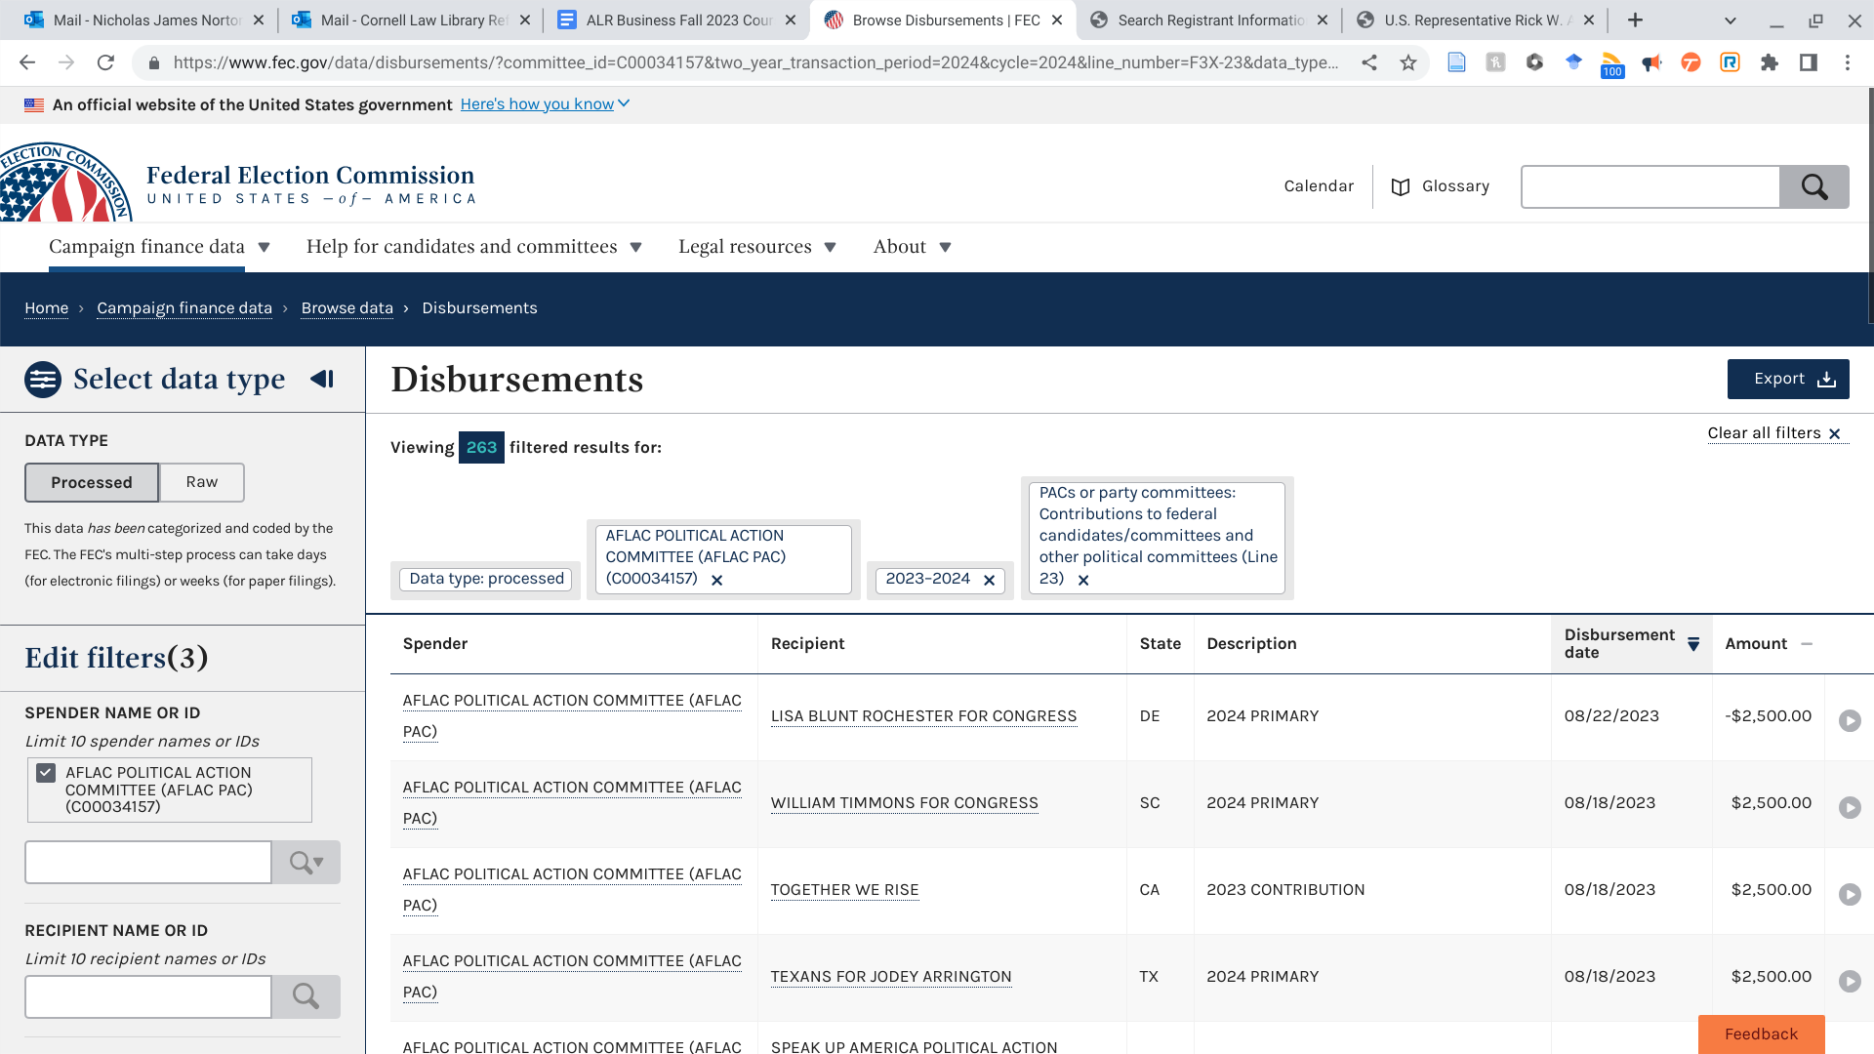
Figure 20. Example results on the Federal Election Commission website to find campaign donations by a corporate political action committee

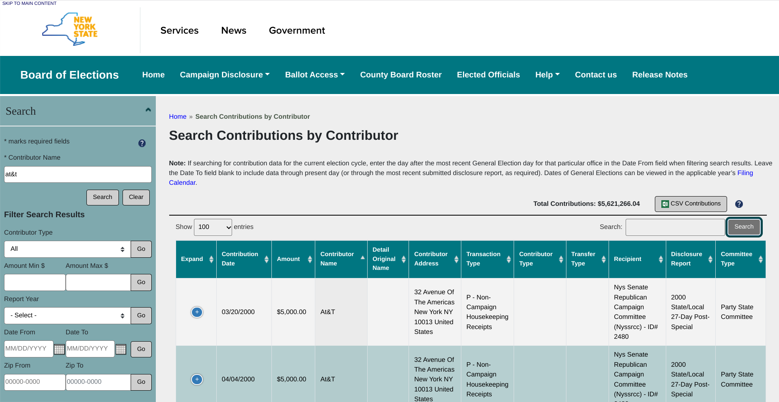
Figure 21. Example New York State political contribution search

7.4 Application

With a partner, discuss the following questions:

- If you had to guess, how difficult would it be to locate campaign finance information about a publicly traded company? How would you locate state and federal election contributions?
- In your own words, what is a lobbyist?
- Now visit https://www.fec.gov/campaign-finance-data/lobbyistregistrant-committees-file-description/ and use the glossary to look up the definition of a lobbyist. How do your definitions compare?
- In what contexts might you need to research campaign finance information while researching a business?

7.5 Concluding Exercises for Chapter 7

Campaign Finance Exercise 1

- Pull up campaign finance information for T-Mobile on the FEC website. What data is available? Describe your path to finding the information.
- Who is the CEO of T-Mobile?
- Using the FEC website, has the CEO of T-Mobile made any campaign contributions recently? List one below if they exist.

Campaign Finance Exercise 3

- Visit the FEC website. List any data you locate on campaign contributions done by Home Depot's political action committee.
- Based on data on Home Depot's political action committee, what is the total individual contributions this committee has received?
- On 8/7/2023, the Home Depot political action committee made campaign contributions in what state?
- Who is the CFO of Home Depot?
- Has the CFO of Home Depot made any political contributions? Link to their contributions on the FEC database.

Chapter 8: Foreign, Comparative, and International Business Legal Research

8.1 Learning Objectives for Chapter 8
Reading this chapter will help students understand:

- How to find non-U.S. company information
- Practice locating business laws of non-U.S. jurisdictions

8.2 Introduction

Throughout this text we have gone over the different permutations of company information that exists for United States based companies. As we all know, however, not every company is located in the United States. How would a researcher gather information on a foreign or international business? This chapter introduces sources to get a legal researcher started with answering that question.

8.3 Basics of Non-U.S. Legal Research

When conducting legal research on a non-U.S. jurisdiction, that is often referred to as foreign, comparative, and international legal research. Foreign legal research refers to the examination of a country’s domestic law. For example, if you are not in Mexico and that country’s laws do not apply to you, then researching Mexican family law would be researching law in a foreign county. International legal research refers to researching the laws between countries. For example, researching trade agreements, United Nations, or the International Criminal Court. Comparative research in this context might involve comparing different legal systems to one another. For example, comparing family law in Canada, the United States, and Mexico.

The following are useful to keep in mind when starting legal research that involves foreign, comparative or international legal research:

- What jurisdiction are you researching?
- Is this jurisdiction a common law or civil jurisdiction?
- What topic area are you researching in that jurisdiction?
- Is there a secondary source (treatise or commentary) on that issue for that jurisdiction?
- What primary sources are relevant?
  - Are these primary sources available only in print?
  - Are these primary sources published online somewhere? (Note they likely won’t be in English if a non-English speaking country)

Answering these questions will aid the legal researcher with getting their bearings on researching an unfamiliar legal system. Below is a screenshot of the GlobalLex database and searching for an introduction to Canadian law.

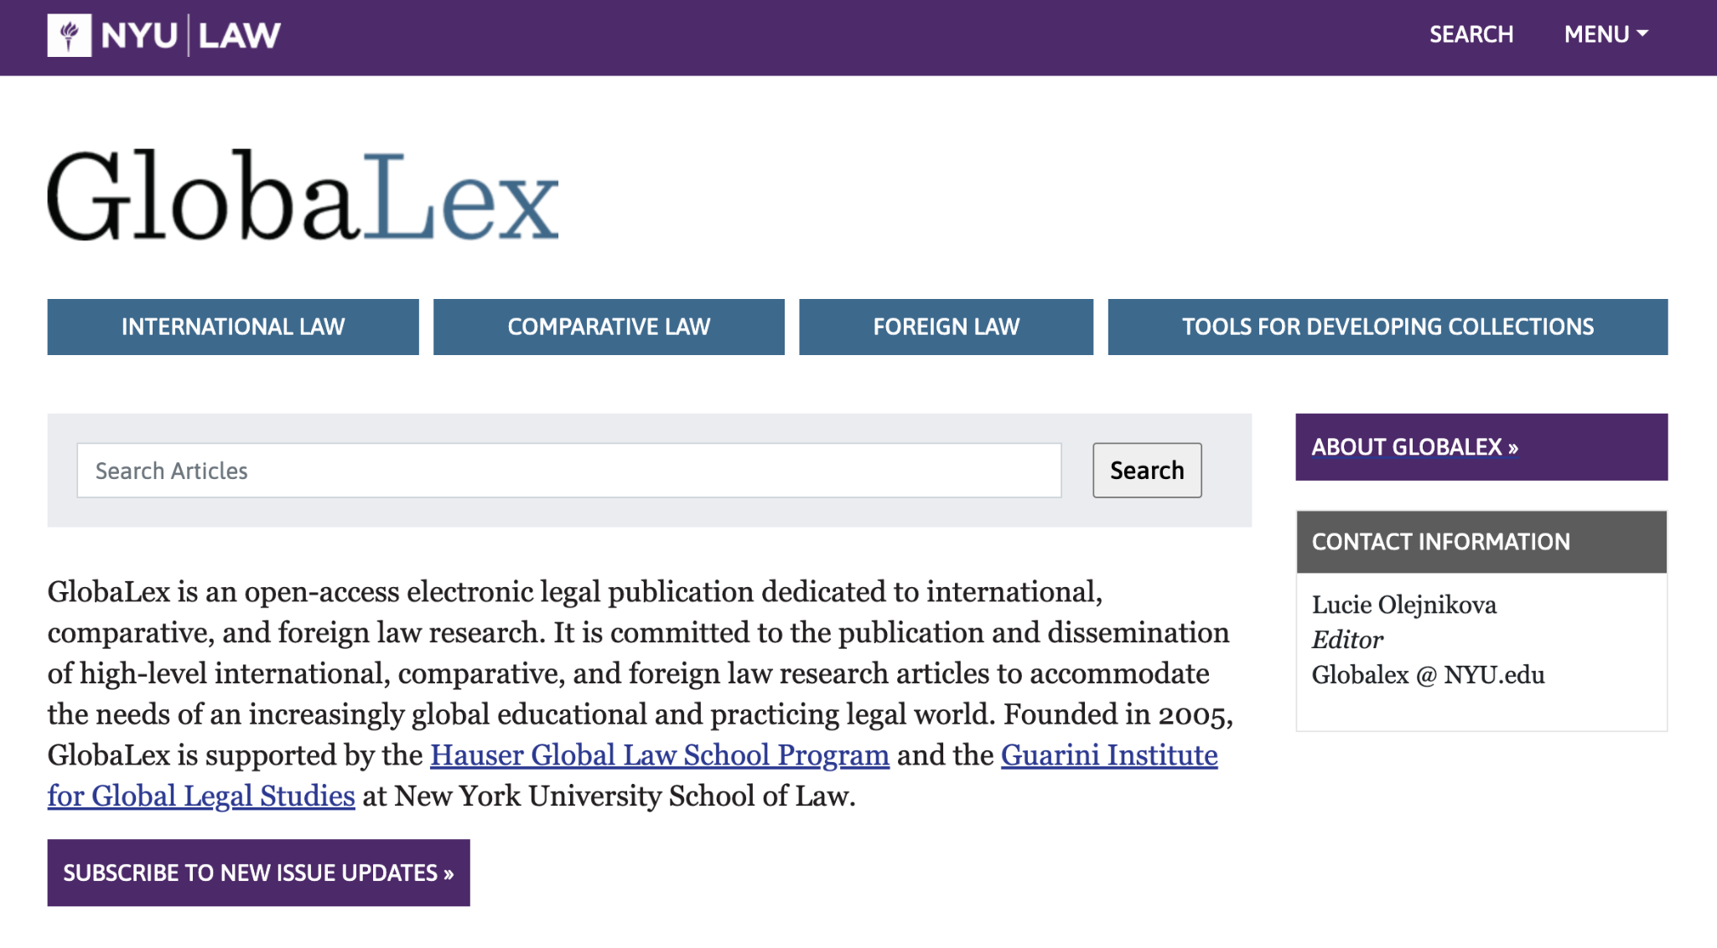
Figure 22. The interface for searching for a country research guide on GlobaLex

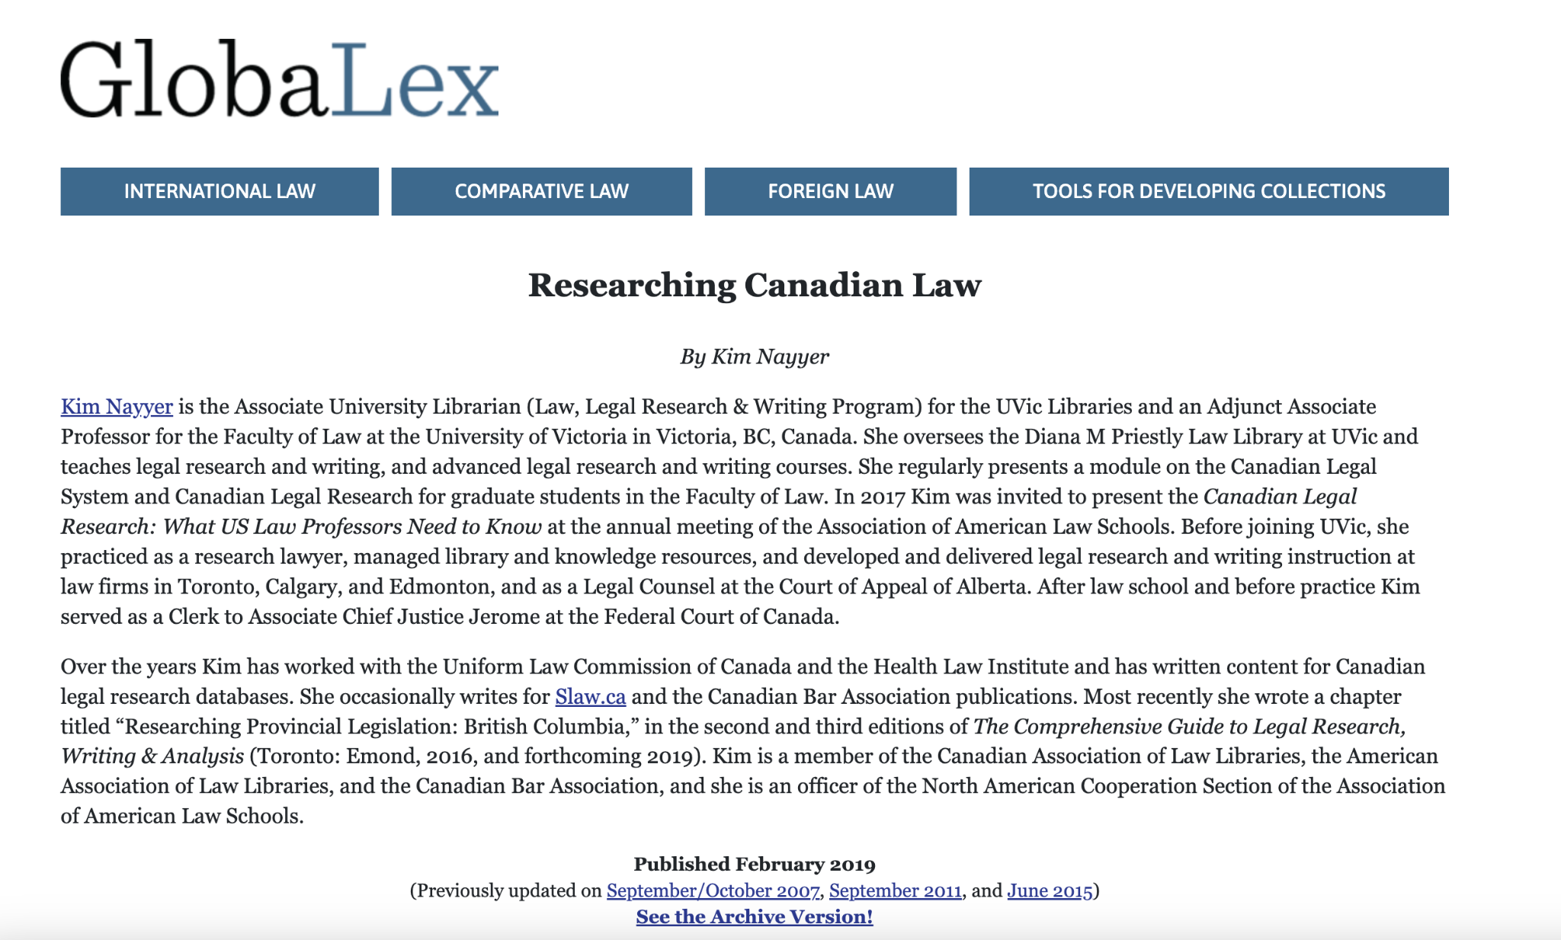
Figure 23. The Researching Canadian Law guide written by an expert in the area

8.4 Basics of Non-U.S. Company Information

Most countries have a central company registry. For example, in the United Kingdom a company must register with “Companies House.” Contrast that with the U.S. where companies are registered in an individual state or territory where a legal researcher will have 50+ places to look for company registration information. Non-U.S. companies must register ownership, but are not necessarily required to disclose the same financial information that a publicly traded company in the U.S. would with the SEC (that will vary depending on the jurisdiction). Below is an example of looking up a company profile for Samsung on Bloomberg Law. Next is a screenshot on a database called DART (Data Analysis Retrieval and Transfer) database used for Korean corporate filings. This database is searchable in English but note that will not be the case for many countries. If you are having difficulty locating information for a particular foreign company, consult your employer or a librarian for assistance.

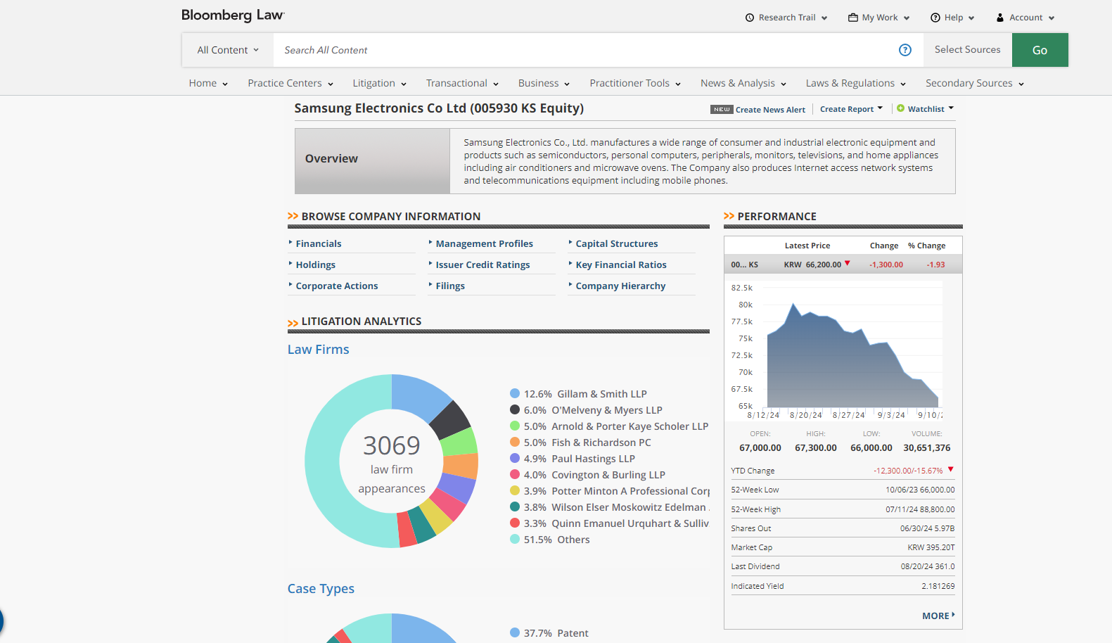
Figure 24. Example Bloomberg Law Company Dashboard for a non-U.S. company.

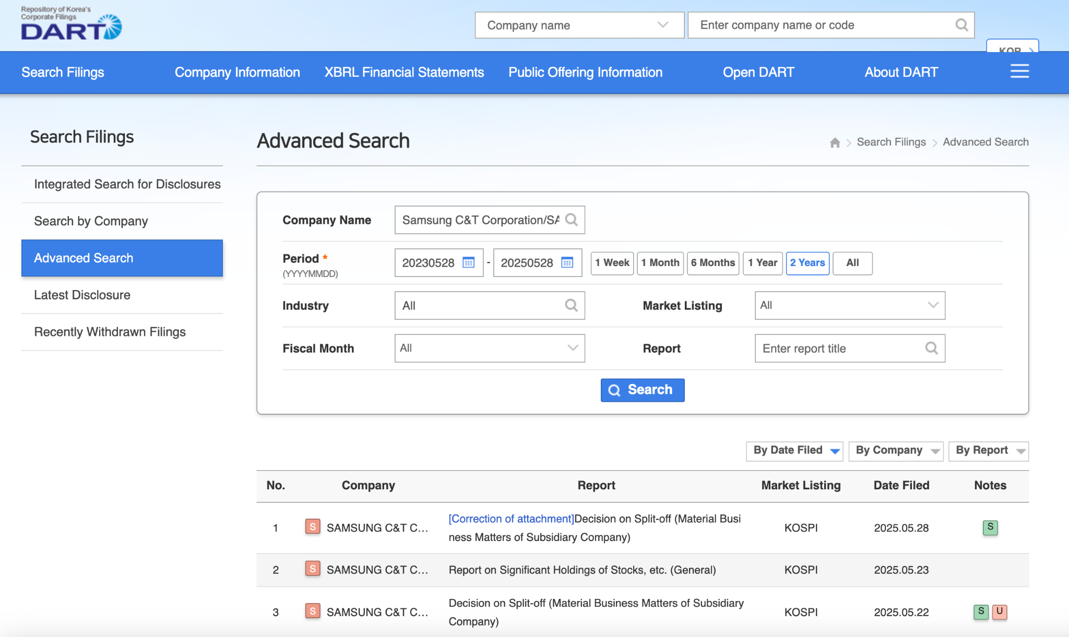
Figure 25. The DART (Data Analysis Retrieval and Transfer) database used for Korean corporate filings.

If the legal researcher is trying to find the law of other countries, they can consult sources like Getting the Deal Through on Bloomberg Law or Practical Law on Westlaw.

8.5 Application

You are being asked to find commentary on international law related to commercial real estate in South Korea. Find links to each of the sources described below:

1) Head to https://guides.loc.gov/foreign-law. Find a link to a guide on South Korea's legal system.

2) Read through the GlobaLex profile on South Korea https://www.nyulawglobal.org/globalex/south_korean_legal_resources.html. Do any of the sources discuss business law in South Korea? If so, which one would you look at first?

3) Go to Westlaw and select Practical Law. From there, navigate to the bottom right of the page and select "global guides and cross border topics." Select commercial real estate, and find a guide on the topic on commercial real estate in South Korea.

4) Using the guide you just found on Practical Law, answer the following: Are there restrictions on foreign ownership or occupation of real estate (including foreign ownership of shares in companies holding real estate)?

The answer will be apparent from reading the selection on Practical Law. If, however, you do not have access to Practical Law, identify a source from the GlobaLex article that you could access online or in print at a library near you to investigate further.

8.6 Concluding Exercises for Chapter 8

Check Your Knowledge Exercise

George is trying to locate statutes from when England still had the death penalty in the 1950s.
Which of the following sources is going to be potentially helpful?

- Article: Researching the Law of the United Kingdom on GlobaLex
- Foreign Law Guide article on the United Kingdom’s legal system
- BAILII, which publishes free primary sources
- All of the above

Looking Up An International Company

Use both Bloomberg Law business intelligence center and Hoover’s Company Reports on Lexis+, pull up a profile for Thomson Reuters and answer the following:

- What country is this company based out of?
- Using Google, are you able to find a corporate registry for that country?
- If you found a corporate registry, what company information is or is not available?

Appendix A - Writing a Due Diligence Report Exercise

Select a public company and prepare a modified due diligence report using resources like SEC filings, Bloomberg Law, Lexis Nexis, etc. The paper shall be 7 – 10 pages.

The report may be organized in any way you choose. Please indicate the sources used to find the information—use a variety of sources. Do not cut and paste; rather, your distillation of information is expected. Your report should include:

- Name of entity
- State of incorporation
- Main office address and contact info
- Current key board members and top officers, including relevant information about them
- Executive compensation for Board Chair and CEO
- NAIC and SIC codes
- Discussion of company website
- Short corporate history
- Number of employees
- Competitors
- Stock history over past year
- Relevant SEC filings—what did they report?
- Basic financial information, e.g. annual sales, percent growth, net income
- Citation and summary of recent news articles and press releases
- Synopsis of analyst reports/coverage
- Your analysis of the company

Add anything of interest or that you believe is pertinent. Do not copy an existing report, instead provide your own analysis. Carefully consider your sources when putting together your final report.

Appendix B - Compliance Lighting Talks Exercise

Imagine you are a new associate in a general counsel’s department at a corporation. Your supervisor gives you a multitude of reports to read on your company’s history to get you up to speed. After digesting hundreds of pages of information on your company’s history, the supervisor in the elevator asks you to describe the most important information you’ve learned about this corporation from your review of the documents they provided. Your presentation should cover the following:

- Company name
- State of incorporation
- Industry
- Very very short corporate history (one to two sentences)
- Competition overview
- Litigation overview
- Regulation overview

Your presentation should be no more than five minutes in length and not require the use of visual aids. You may use notes but use them sparingly (try not to read your content verbatim off the notes). Try to pick out the key facts of each of the listed areas above and memorize them if possible.

Rubric

- Time management: was the presentation within the 5 minute time limit? (1 point)
- Thoroughness: are all topic areas above covered? (2 points)
- Accuracy: are all statements accurate during the presentation? (3 points)
- Sourcing: were an appropriate number of sources utilized to research the topic (2 points)
- Presentation: was the speaker able to effectively manage their time, deliver the content, and clearly communicate their message to the audience? (2 points)

Legal research in a nutshell, (Kent C. Olson ed., Fourteenth edition ed. 2021).
See generally Sources of American Law: An Introduction to Legal Research | CALI, https://www.cali.org/books/sources-american-law-introduction-legal-research (last visited Aug 20, 2024).
See LexisNexis Introduces Protégé Personalized AI Assistant with Agentic AI, Making it Easier to Power Complex Legal Task Completion | LexisNexis PressRoom, https://www.lexisnexis.com/community/pressroom/b/news/posts/lexisnexis-introduces-protege-personalized-ai-assistant-with-agentic-ai-making-it-easier-to-power-complex-legal-task-completion (last visited Apr 17, 2025)
How Thomson Reuters Supercharged CoCounsel With Gen AI Advances, Above the Law, https://abovethelaw.com/2024/10/how-thomson-reuters-supercharged-cocounsel-with-gen-ai-advances/ (last visited Apr 17, 2025)
AI and Attorney Ethics Rules: 50-State Survey, Justia, https://www.justia.com/trials-litigation/ai-and-attorney-ethics-rules-50-state-survey/ (last visited Apr 17, 2025)
Due Diligence: Types and How to Perform, Investopedia, https://www.investopedia.com/terms/d/duediligence.asp (last visited Aug 20, 2024).
See Adam Eckart, Transactional Skills for Tomorrow, 25 TRANSACTIONS: TENN. J. BUS. L. 769 (2024). See also Lisa Penland, What a Transactional Lawyer Needs to Know: Identifying and Implementing Competencies for Transactional Lawyers, 5 J. Ass'n LEGAL WRITING Directors 118 (2008). Lynnise Pantin, Deals or No Deals: Integrating Transactional Skills in the First Year Curriculum, 41 OHIO N.U. L. REV. 61 (2014).
For an overview of how to find the type of information listed on a publicly traded company, see chapters three and four.
See Due Diligence: Securities Offerings by Practical Law Corporate & Securities https://www.westlaw.com/4-380-7917?transitionType=Default&contextData=(sc.Default)&VR=3.0&RS=cblt1.0 (last accessed December 31, 2024).
Definition of PROFESSIONAL, (2024), https://www.merriam-webster.com/dictionary/professional (last visited Aug 20, 2024).
See Dr. Arin N. Reeves, Written in Black and White: Exploring Confirmation Bias in Racialized Perceptions of Writing Skills, Yellow Paper Series (2014). https://www.ncada.org/resources/CLE/WW17/Materials/Wegner%20_%20Wilson--Confirmation%20Bias%20in%20Writing.pdf
See Constance Z. Wagner, Training the Transactional Business Lawyer: Using the Business Associations Course as a Platform to Teach Professional Skills , 59 ST. LOUIS U. L.J. 745 (2015).
To think through how you would approach multiple conflicting priorities, complete the workflow management exercise at the end of this chapter. Note that there are no completely right answers to the questions presented but it is a useful thought exercise to consider and discuss with others before entering a work setting.
To learn more about using these tools, work through some of the modules on a platform like Write.Law https://trainingtools.thomsonreuters.com/writelaw
See generally: Deborah E. Bouchoux, Fundamental of Business Organizations for Paralegals (2022). It can be helpful to keep a cheat sheet of the differences between the basic entity types such as the one found on the inside cover of this text. Diving into the nuances of all the different corporate forms is beyond the scope of this class, but if you are interested in learning more, consider taking a law school class such as corporations.
For example, see comparison of C-corporation in Delaware vs. California: https://us.practicallaw.thomsonreuters.com/w-001-7859.
For more on using company news tools, see chapter six.
“A SWOT (strengths, weaknesses, opportunities, and threats) analysis is a framework used to evaluate a company's competitive position and to develop strategic planning.” See How to Perform a SWOT Analysis, Investopedia, https://www.investopedia.com/terms/s/swot.asp (last visited Aug 20, 2024).
Eva Su, Cong. Rsch. Serv., Introduction to Financial Services: The Securities and Exchange Commission (SEC), https://crsreports.congress.gov/product/pdf/IF/IF11714.
Matthew M. Morrison, "Due Diligence: Company Information for Law Students," 108 Law Library Journal (2016).
For a complete list of SEC forms see https://www.sec.gov/submit-filings/forms-index.
See https://www.sec.gov/answers/execcomp.htm
https://www.investopedia.com/terms/p/privatecompany.asp
See Zoeanna Mayhook, Privately-Held Companies: Legislation, Regulation, and Limited Dissemination of Financial Information. DttP 47 (2019): 28.
See David Bowie, Contextual analysis and newspaper archives in management history research. Journal of Management History 25.4 (2019): 516-532. See also Leland Bybee, et al. Business news and business cycles. The Journal of Finance (2021).
Ed Dolan, How — and When — Should Companies Engage in the Political Process?, Harvard Business Review, May 2023, https://hbr.org/2023/05/how-and-when-should-companies-engage-in-the-political-process (last visited Sep 10, 2024).
See https://www.fec.gov/help-candidates-and-committees/guides/
For a more detailed explanation of foreign, comparative or international legal research see generally International and Foreign Legal Research: A Coursebook by Marci Hoffman & Mary Rumsey (2012).
If you would like to see if the law of a particular jurisdiction is based on common law system like the U.S., you can consult http://www.juriglobe.ca/.
GlobaLex is an invaluable source of information to locate secondary and primary content on an international jurisdiction. http://www.nyulawglobal.org/globalex/ghana1.htm
You can also consult the Library of Congress research guides on a foreign legal system to get started with international research https://guides.loc.gov/foreign-law.
Some international jurisdictions publish a great deal of their primary law content online. Consult the World Legal Information Institute to see which countries publish a good amount of their legal content for free online http://www.worldlii.org/.
If the researcher does not have access to Bloomberg Law or Westlaw, a possible alternative would be to use GlobaLex to find authentic sources of local laws: https://www.nyulawglobal.org/globalex/# as detailed earlier in the chapter.

